**Classification –Machine Learning Algorithms**

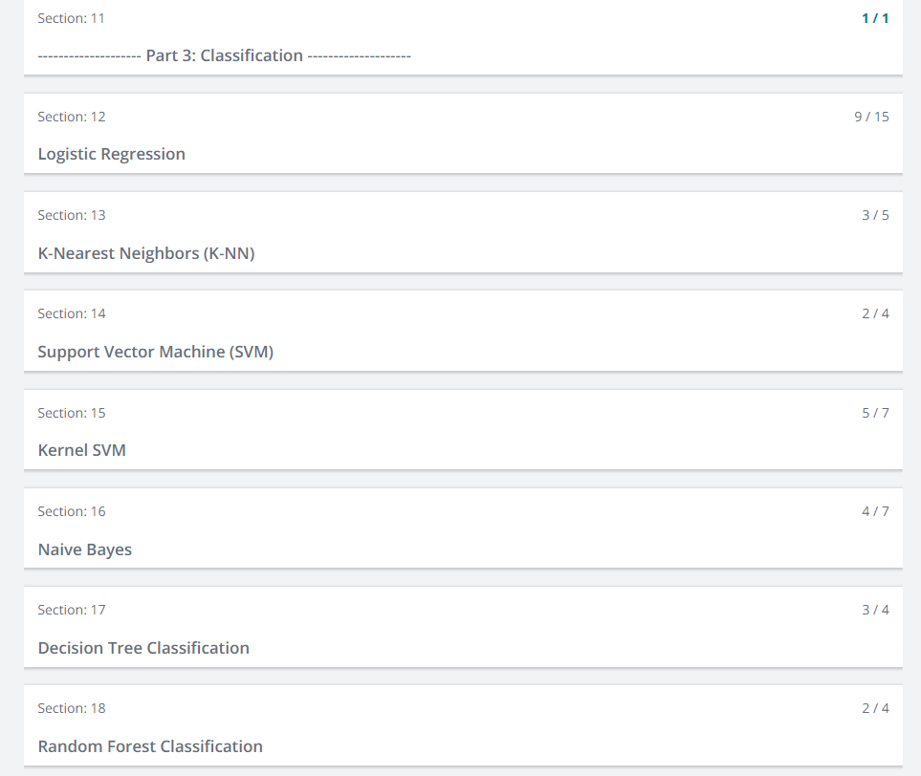

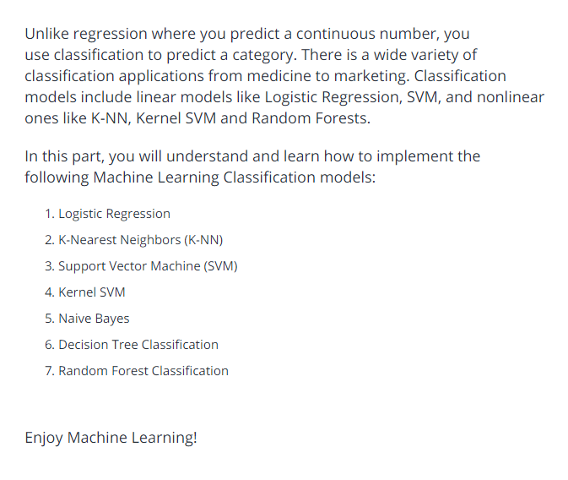

**Logistic Regression:**

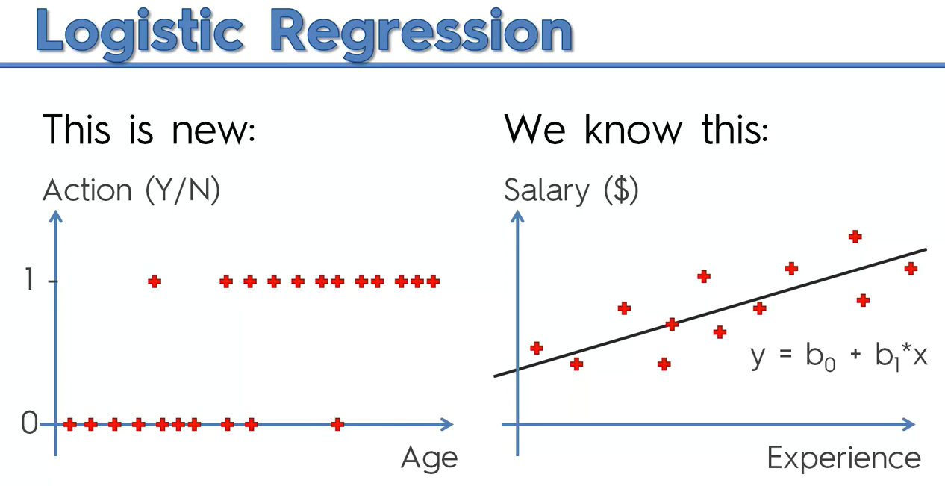

There is some correlation to predict whether customer will buy clothes or not.

If we use linear regression completely, it won’t work.

Take the probability in logistic regression that will help us to solve the problem.

We are modifying linear regression , since there is no >100% and <0%.

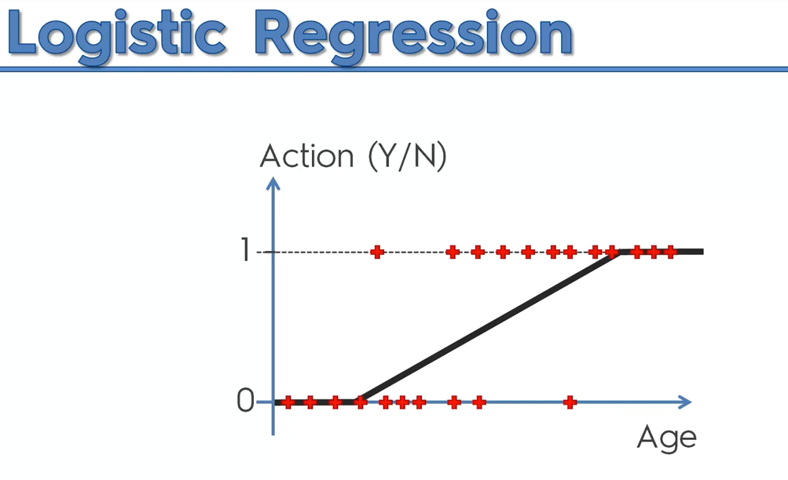

The green box is logistic regression

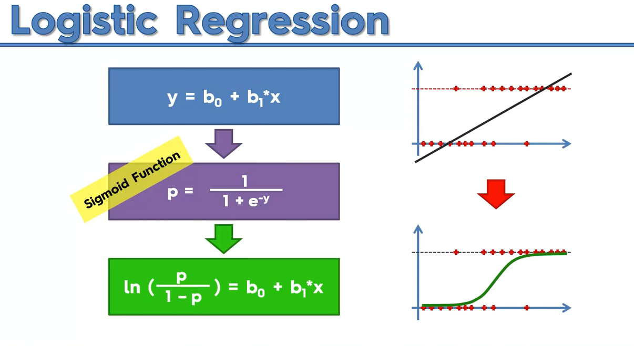

Explanation:

Step 1:

P^ means we are predicting the probability.

Green🡪fitted value

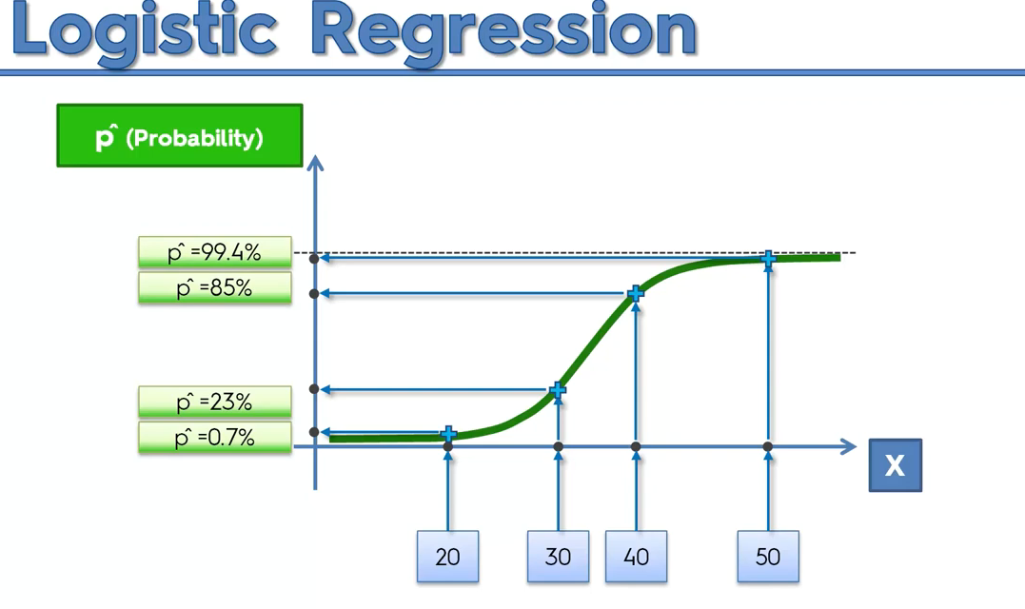

To Predict y^(Predicted Dependent variable),

We will select 50 %, below means 0, greater than 50% then 1.

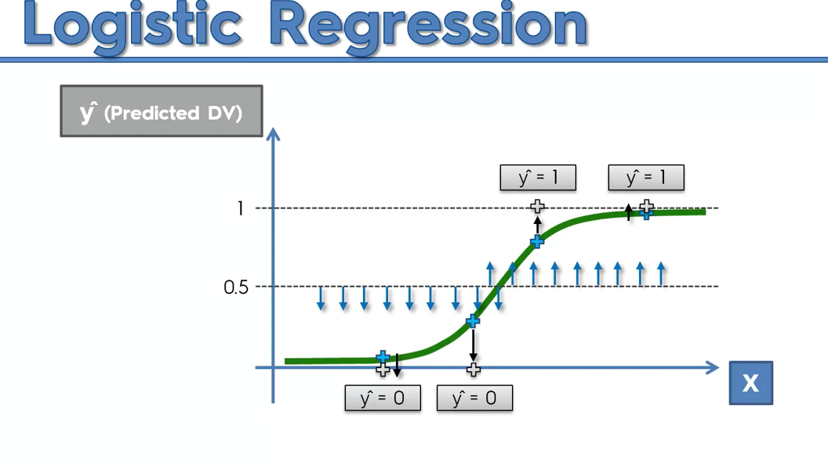

It is also exactly works like linear regression,

* In linear there will be scatter points , we will use slope line
* In classification, we will be predicting binary values, hence we modify the linear regression formula accordingly to predict the probability.
* 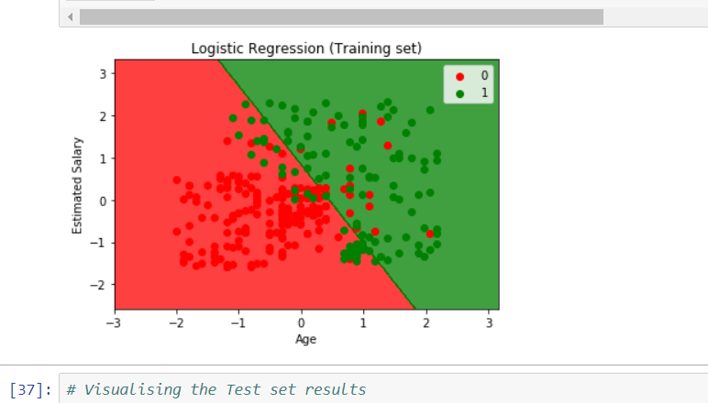

**K-NN**

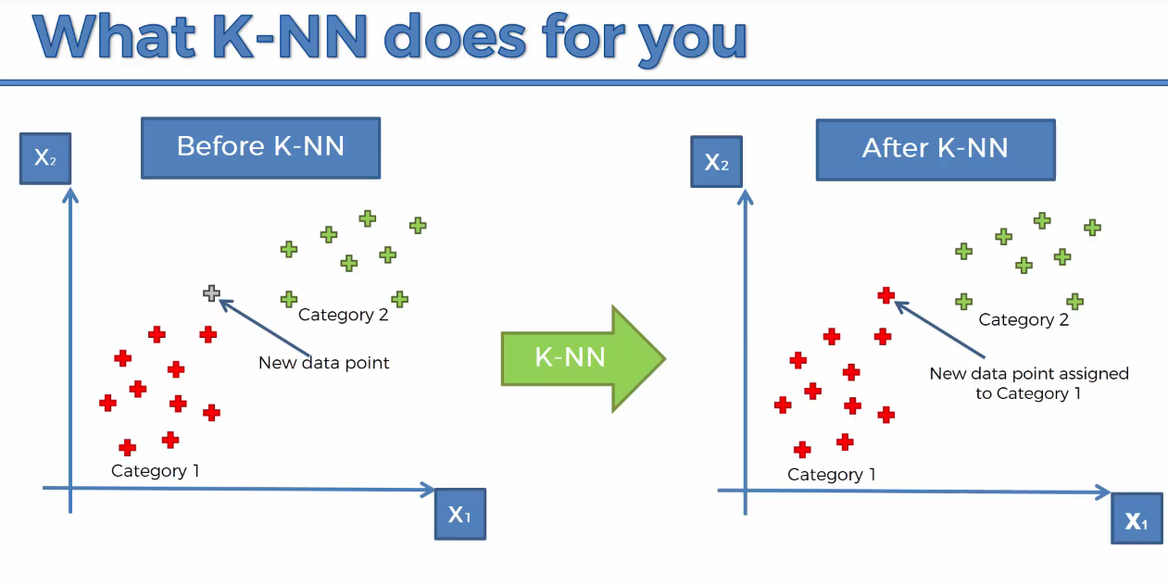

K=5 is default

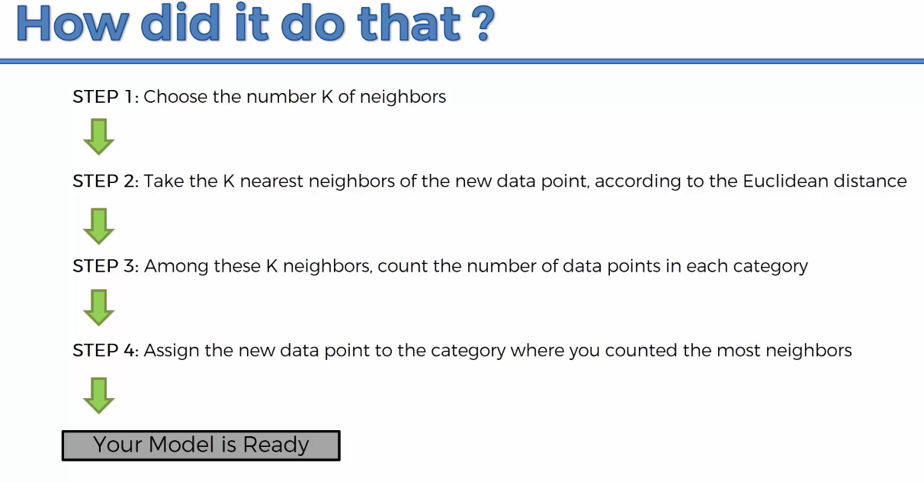

What is Euclidean distance?

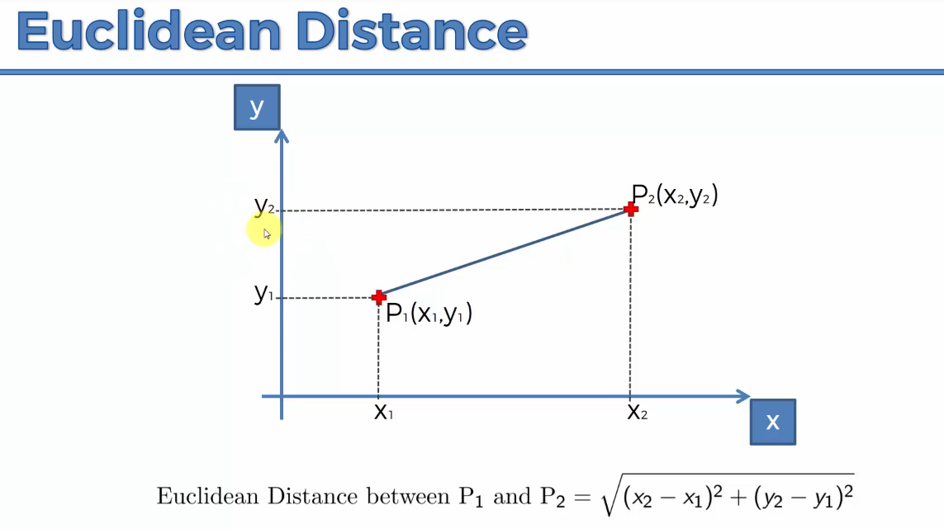

Ie distance between two points.

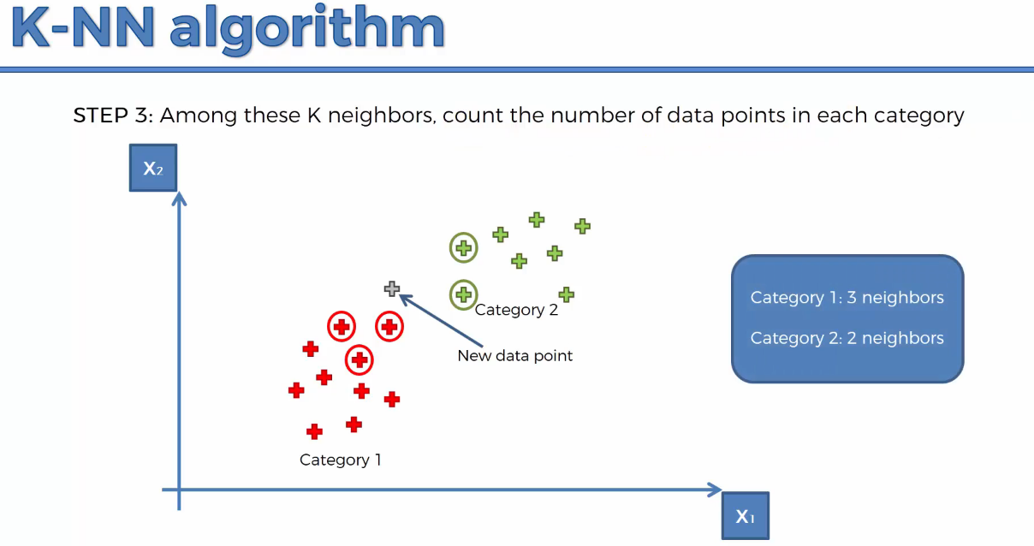

Hence the new data point is assigned as red.

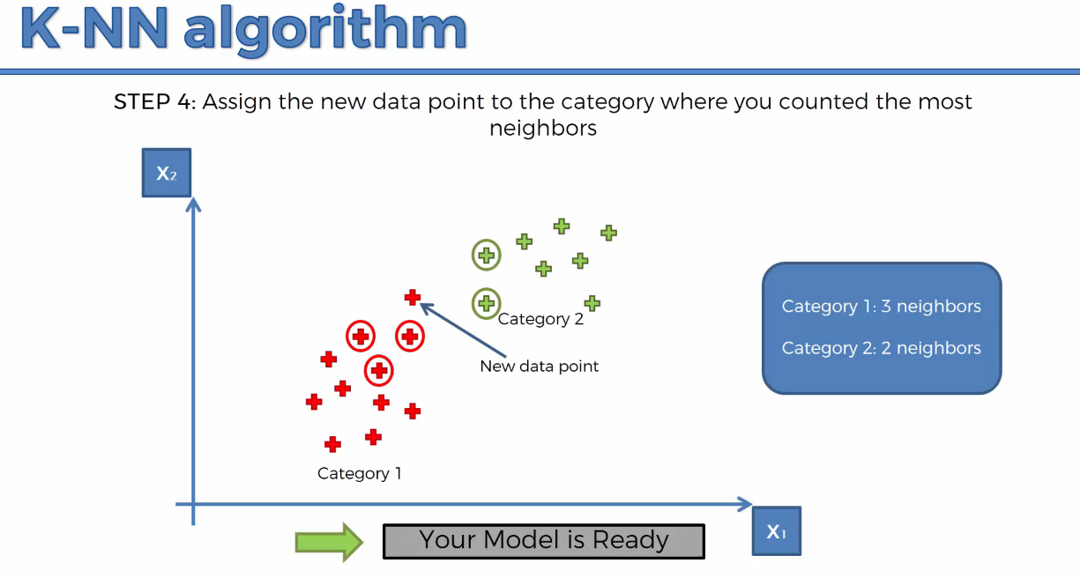

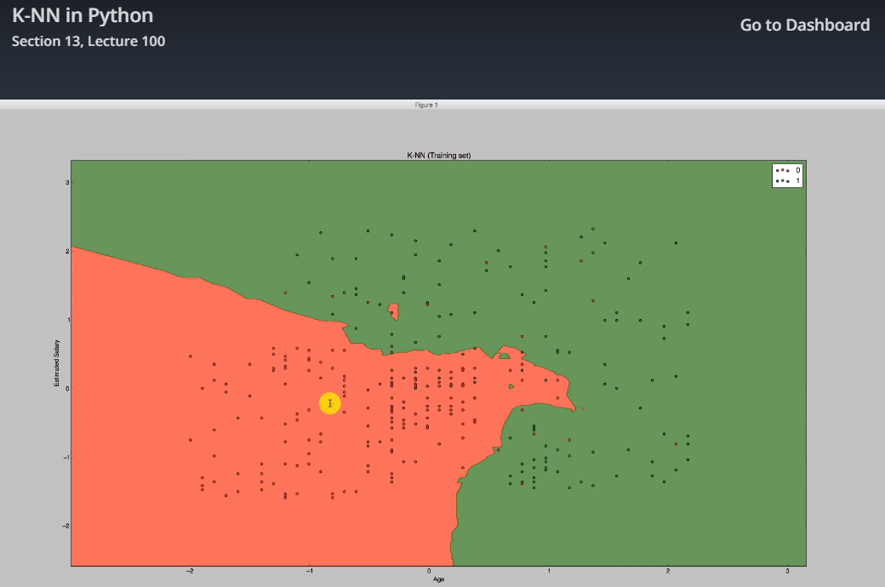

**Support Vector machine-Classifier(linear classifier)**

**kernal can be linear or rbf to make SVM linear or non-linear**

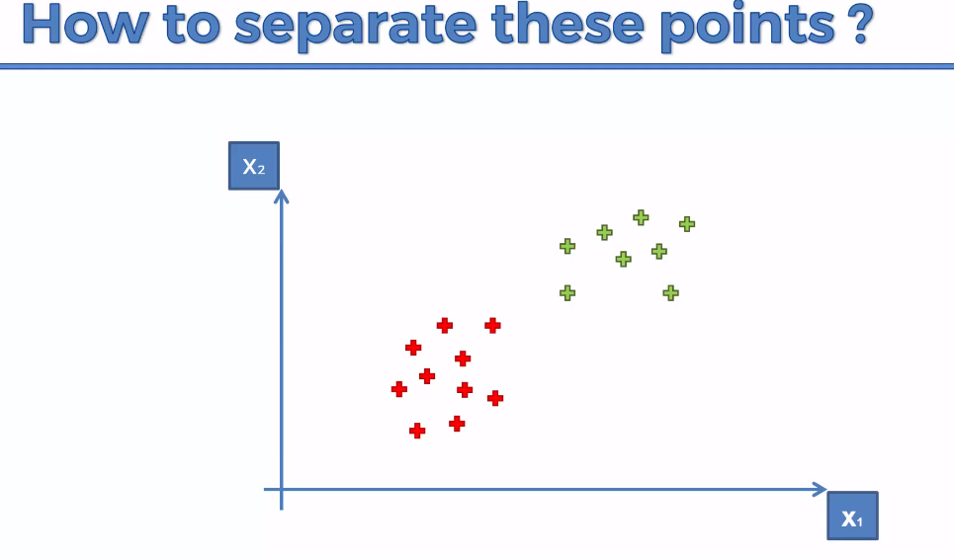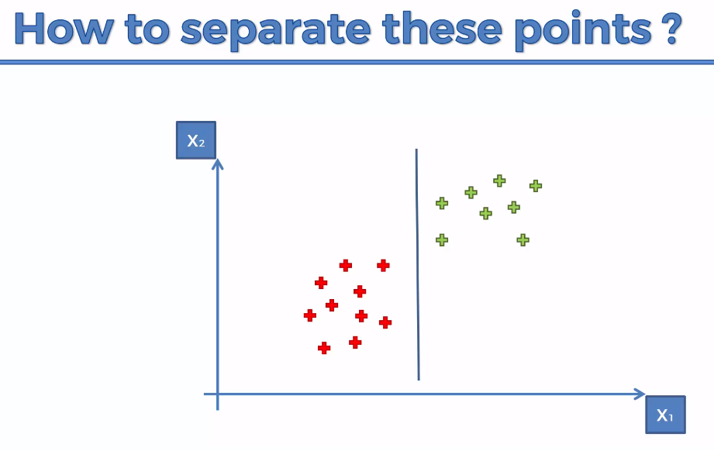

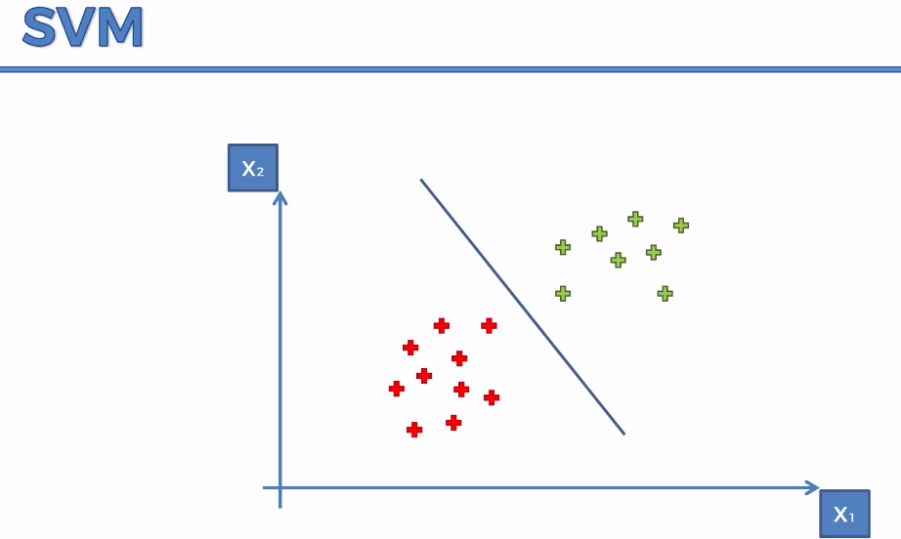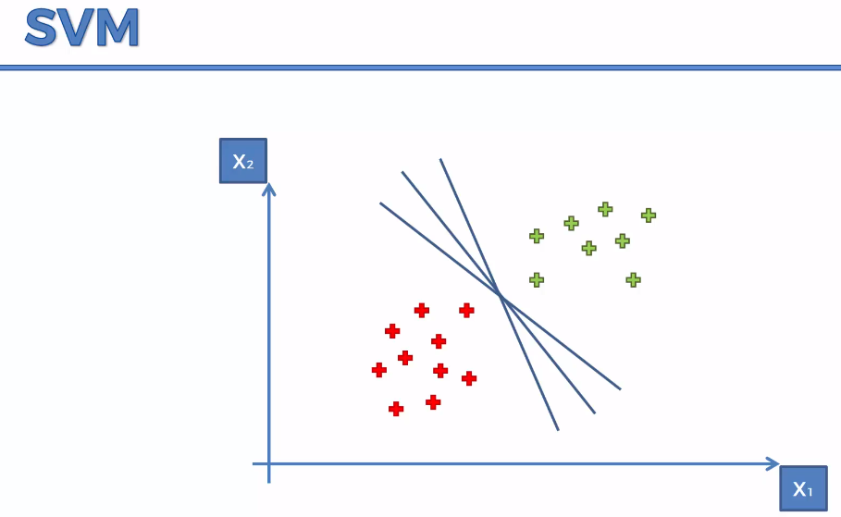

We have to find the optimal line.

Sum of the two line distance should be maximum.

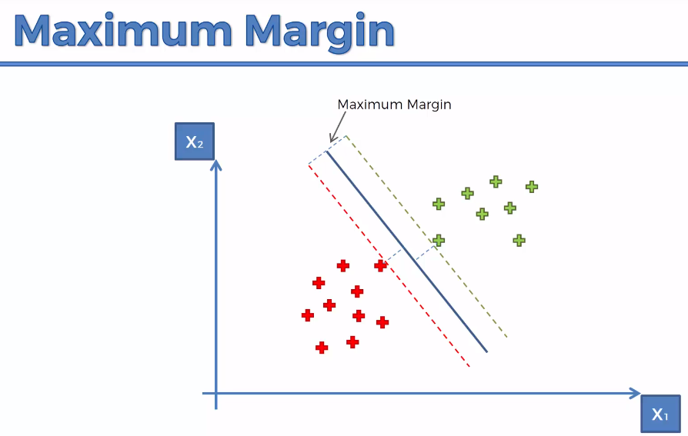 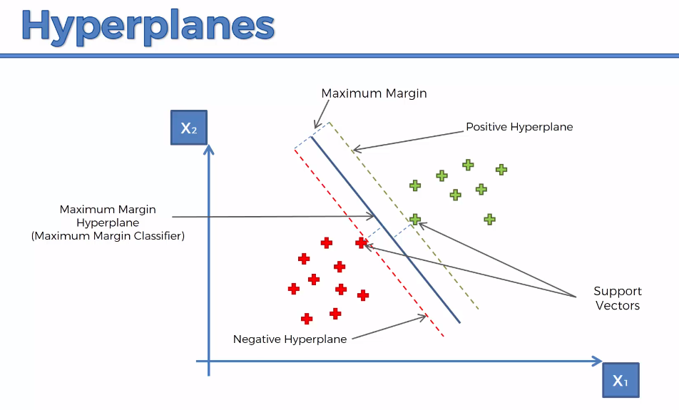

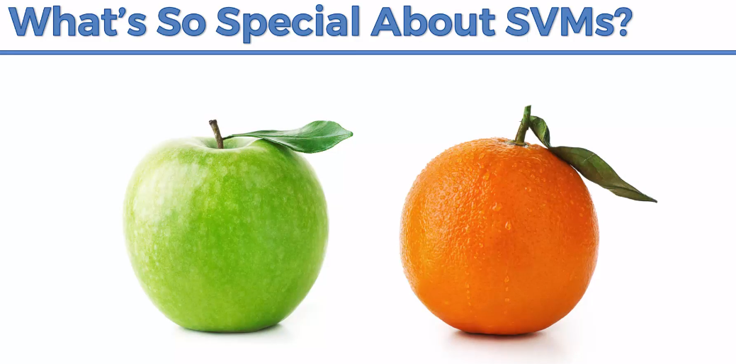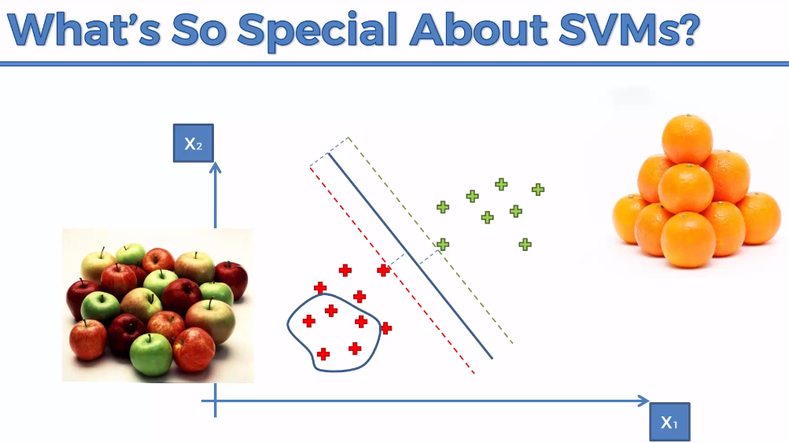

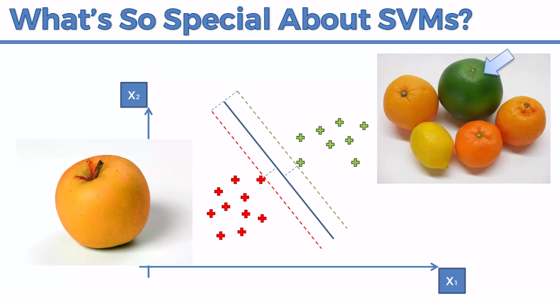

**Result:**

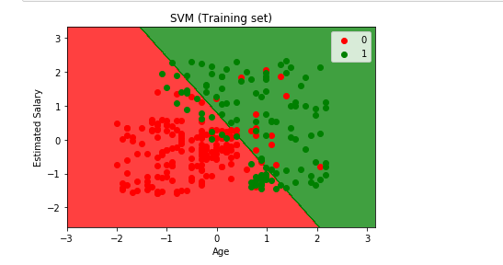

**Kernal SVM**

To handle the below scenario,

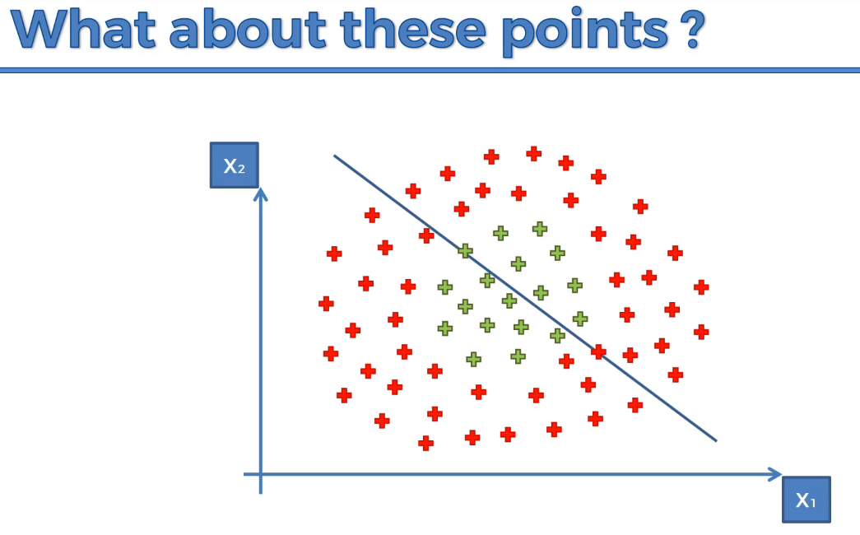

The above approach will fail if we follow linear SVM

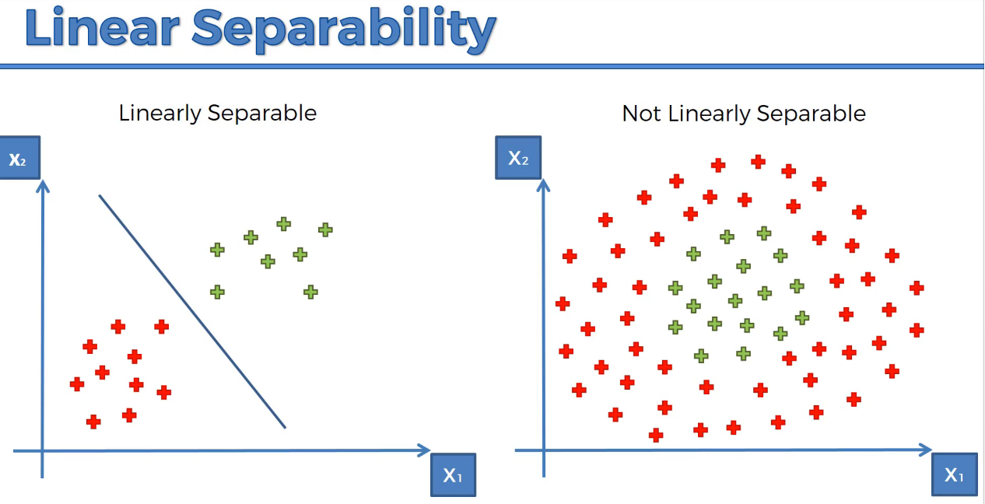

**A Higher – Dimensional Space.**

**1-D**

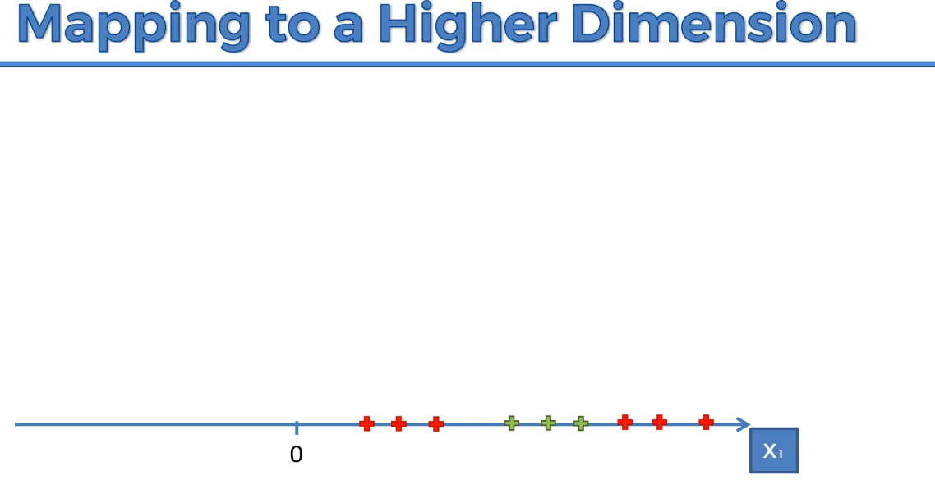

It is non-linearly separable dataset, so we are going to increase the dimensionality

Subtract 5,

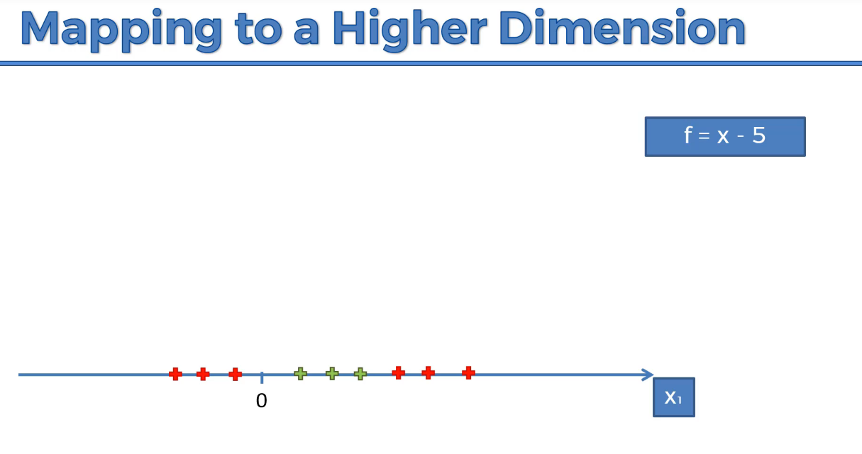

Square with 2

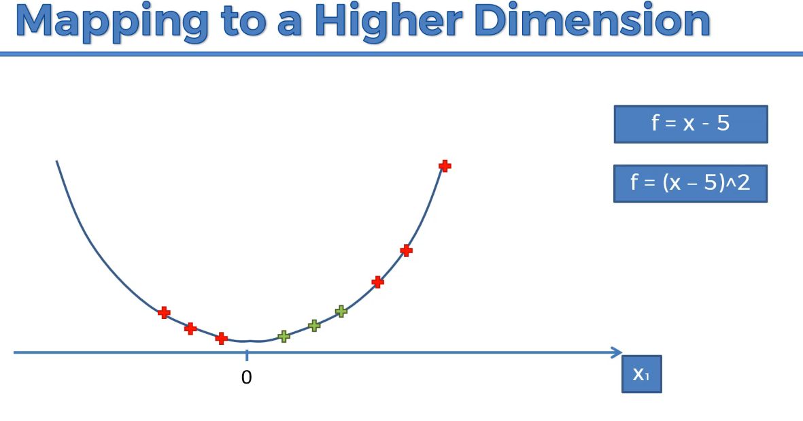

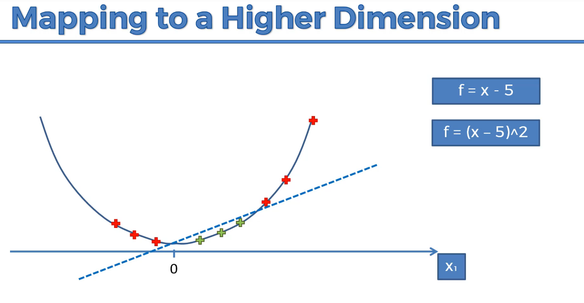

We are able to separate red and green elements.

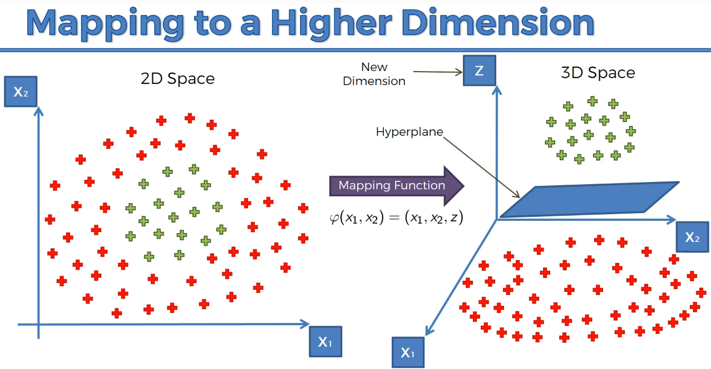

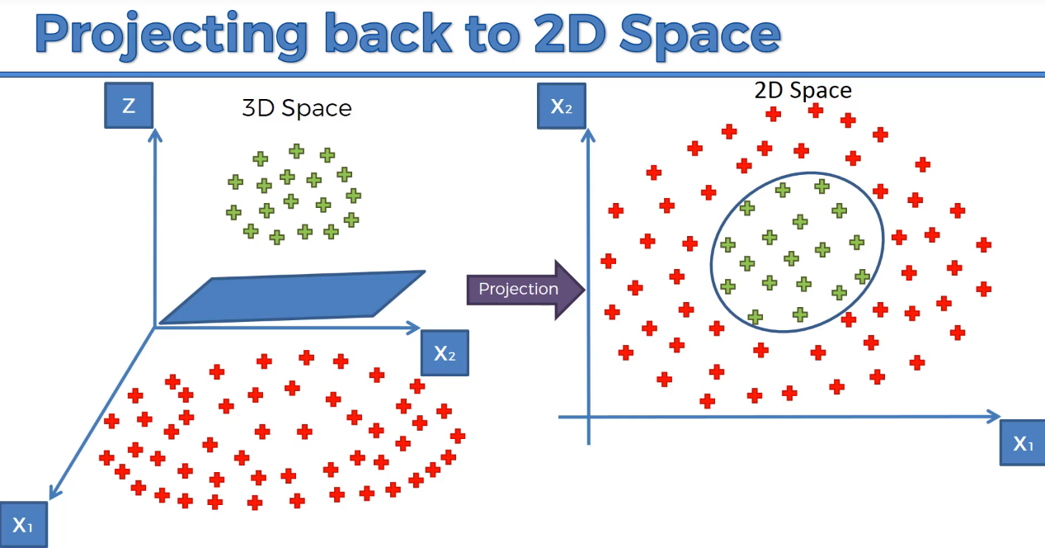

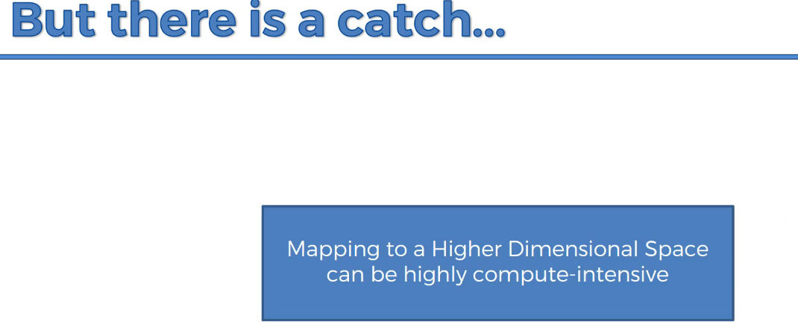

Therefore the approach it is not efficient. It will cause lot of delay. Hence we use Kernal

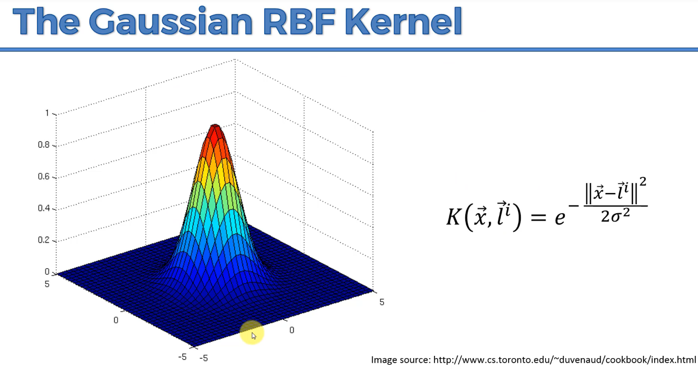

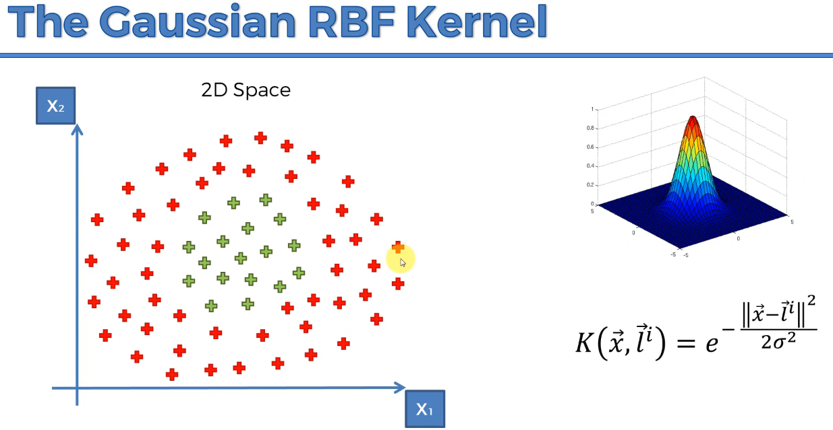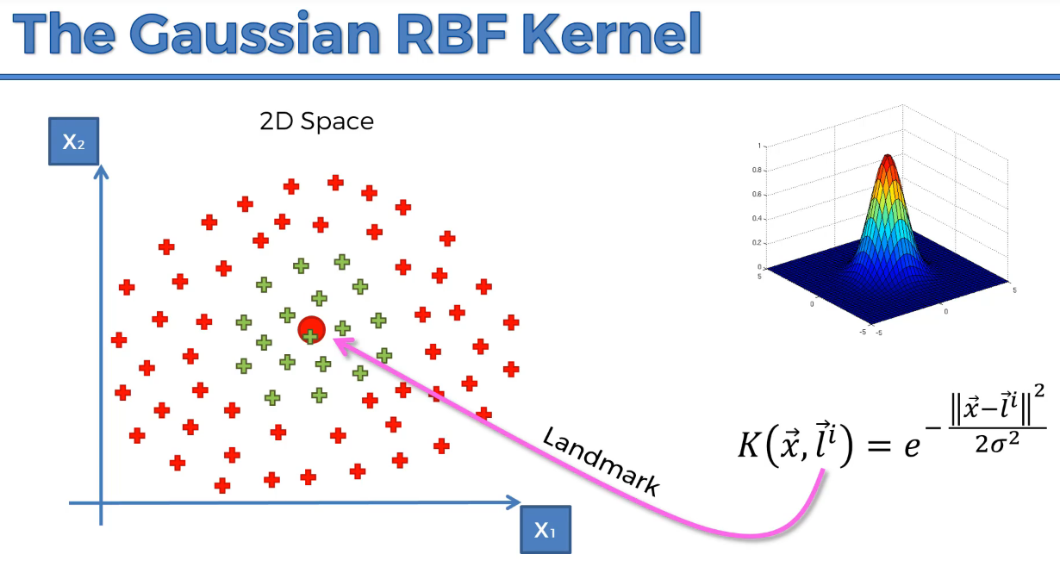

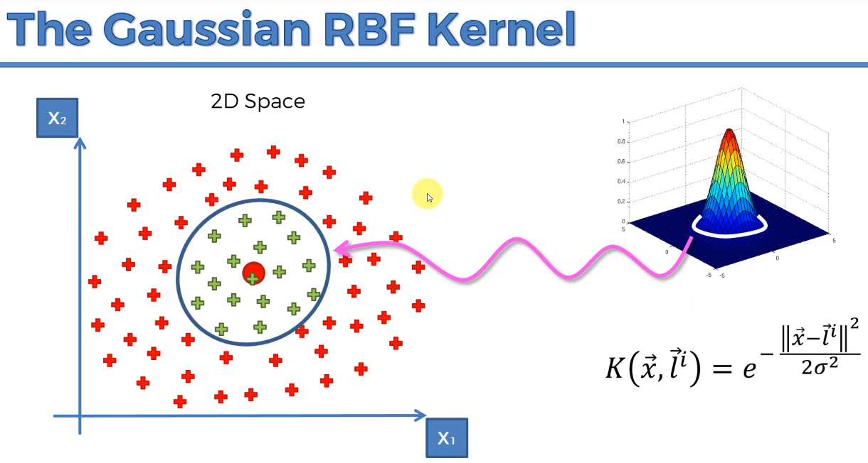

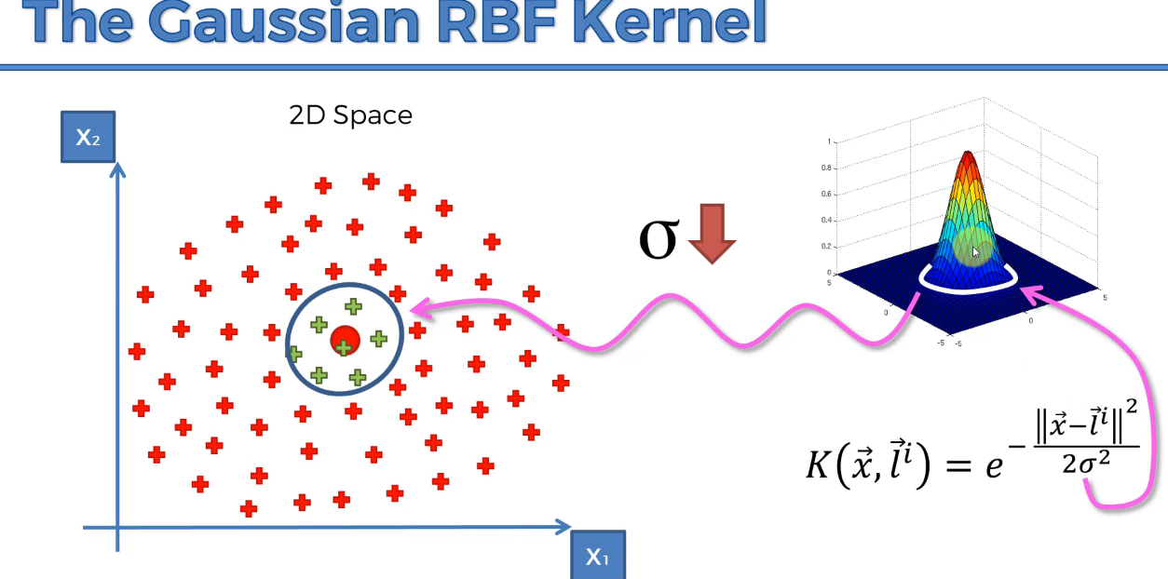

Gaussian RBF kernel can able to compute non-linear datasets, without changing the dimensionality that will reduce the efficiency.

If we have the below problem, change the formula.

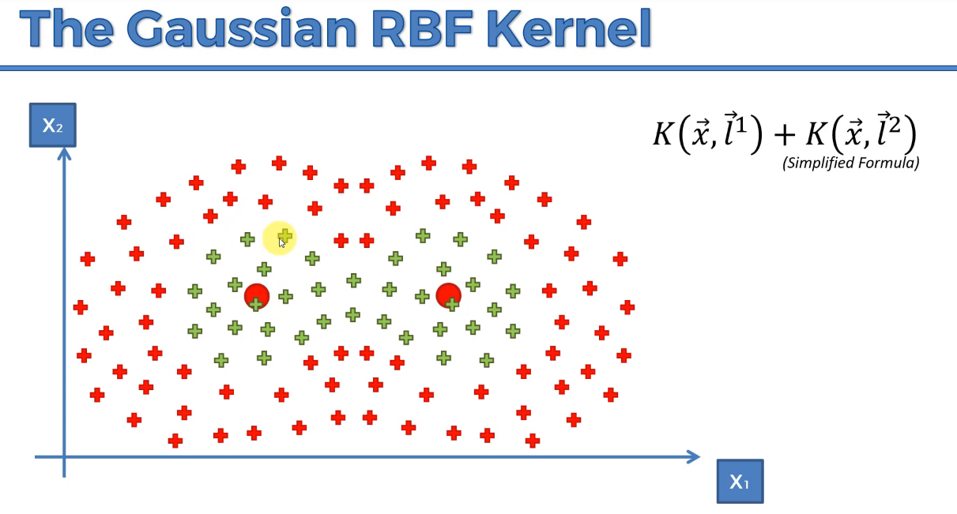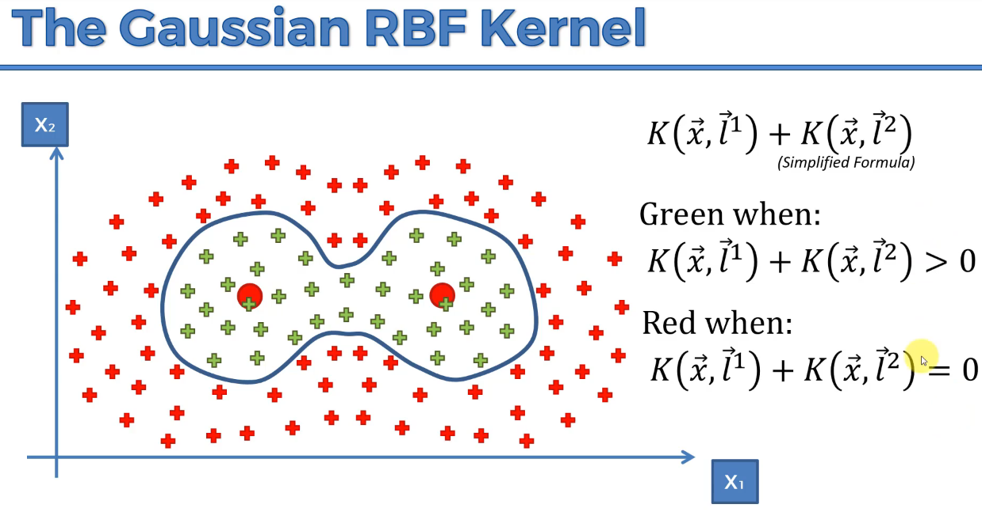

**TYPES of Kernel Functions:**

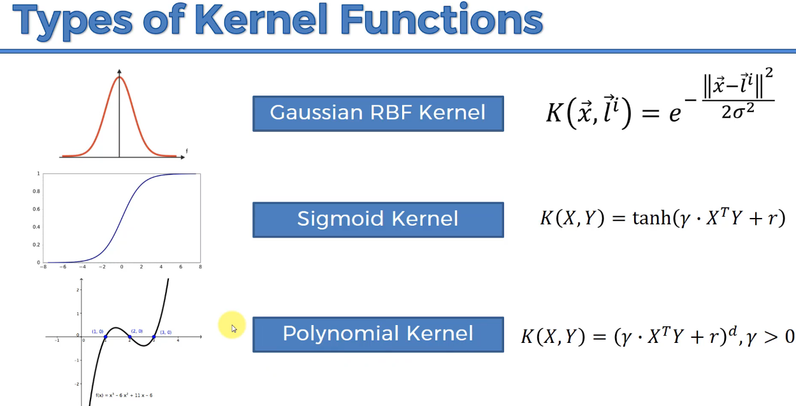

**Bayes’ Theorem**

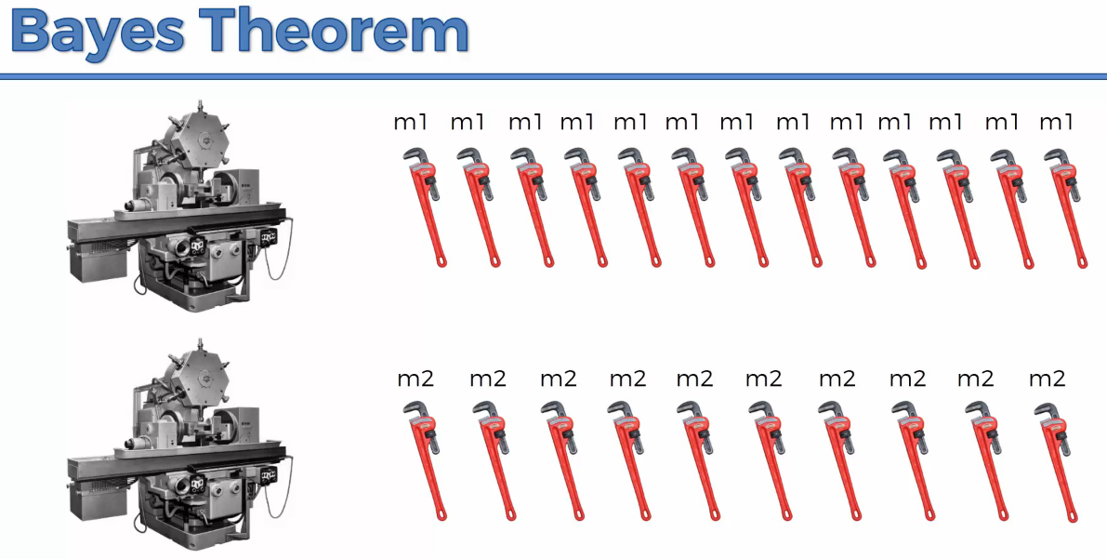

The worker has to pick the defective spanners

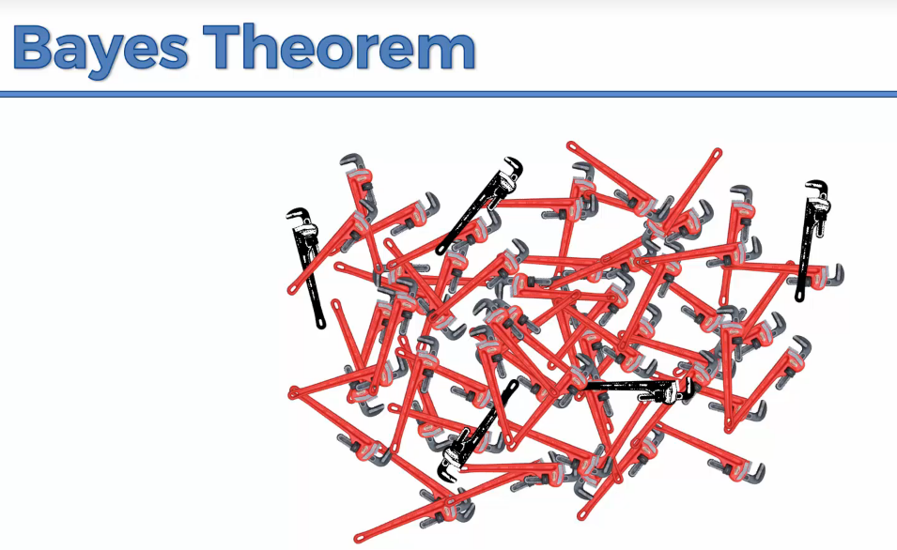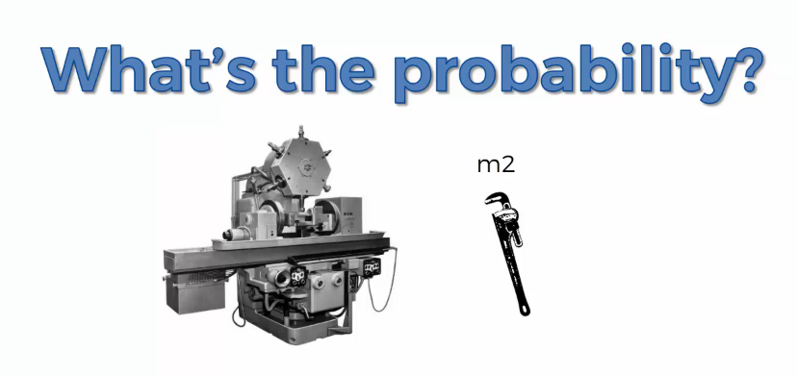

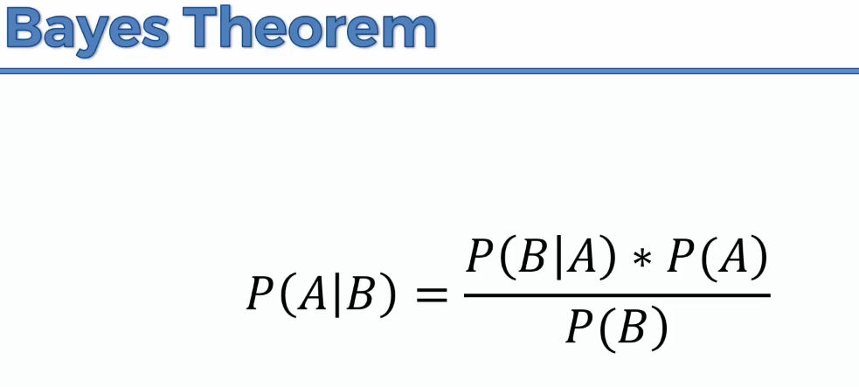

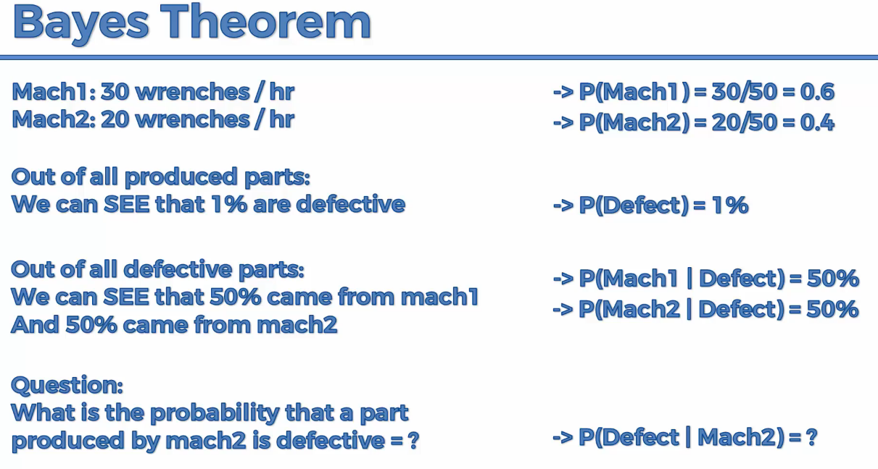

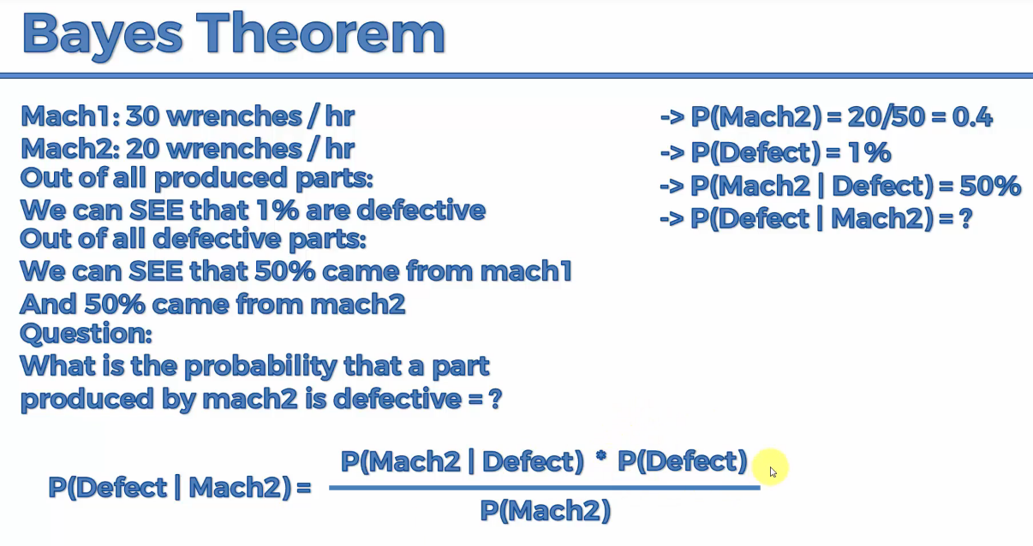

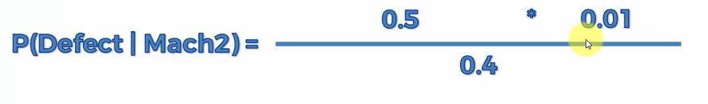

**=0.0125=1.25%**

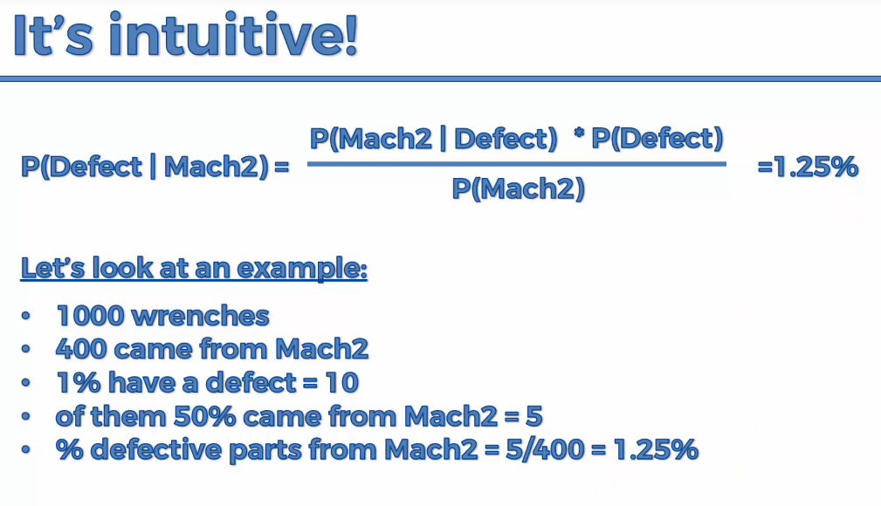

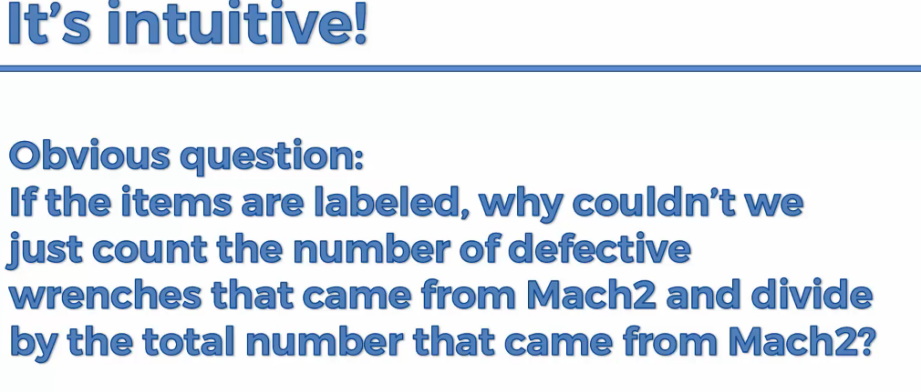

**It is time consuming to check it manually**

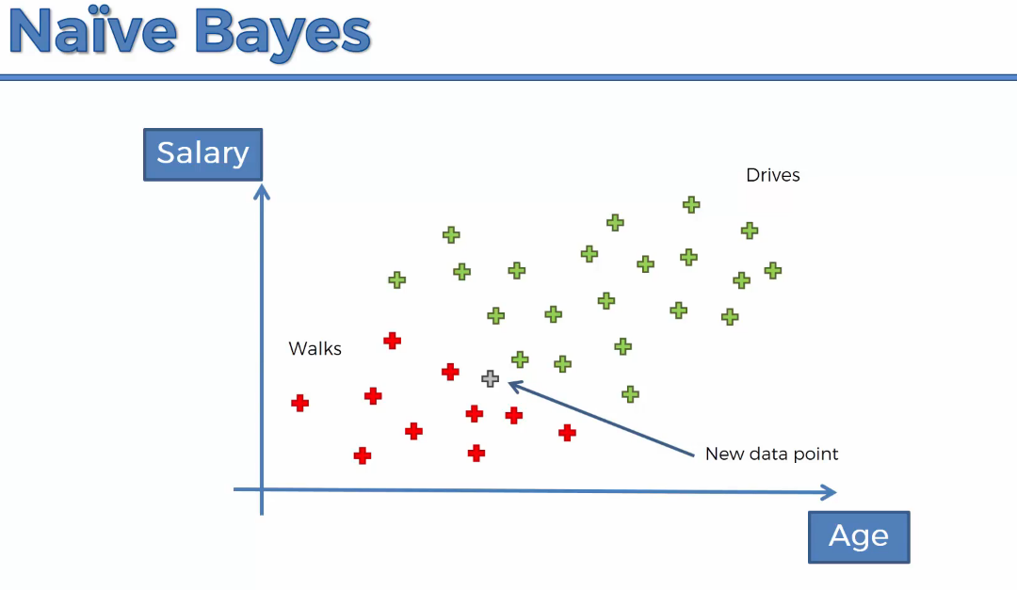

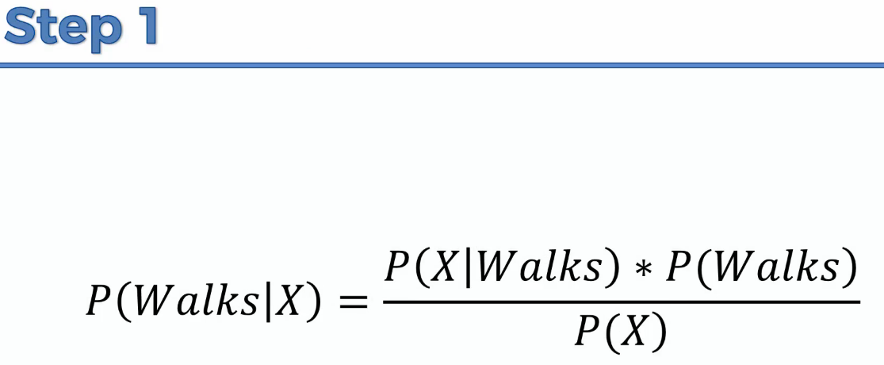

**X🡪features or independent variable.**

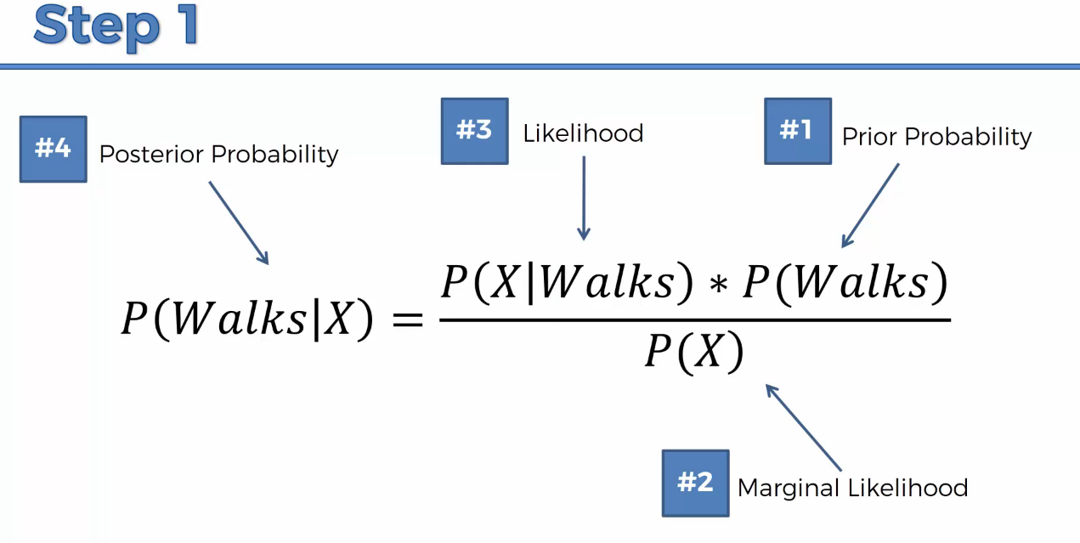

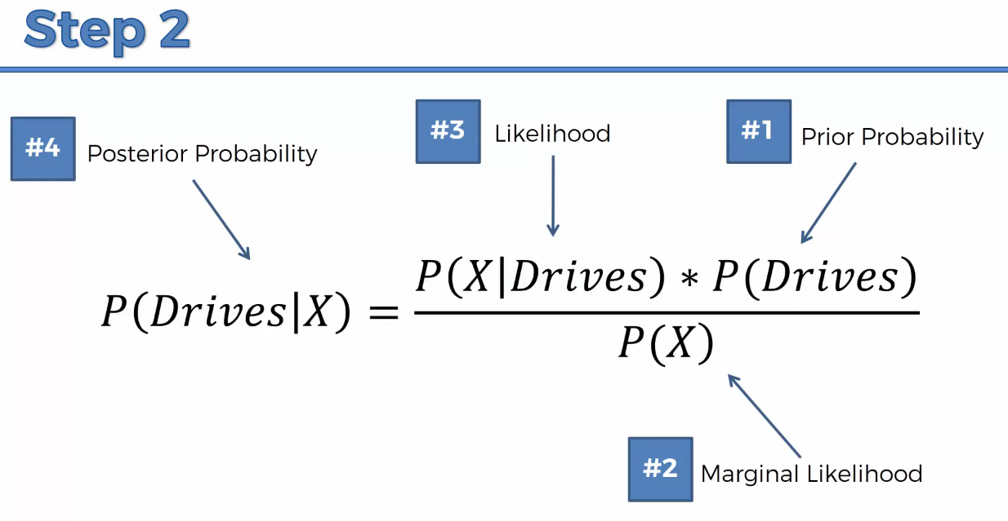

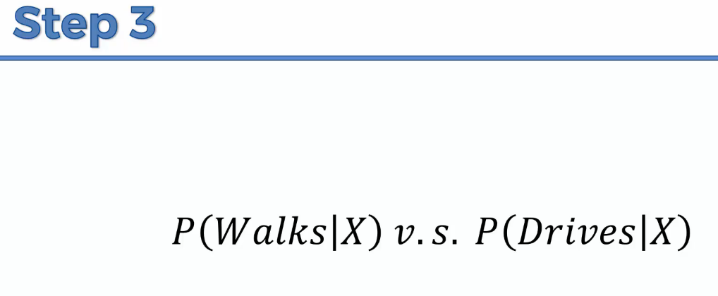

**Solution:**

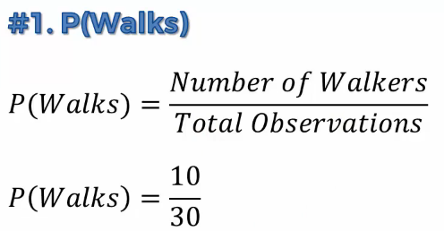

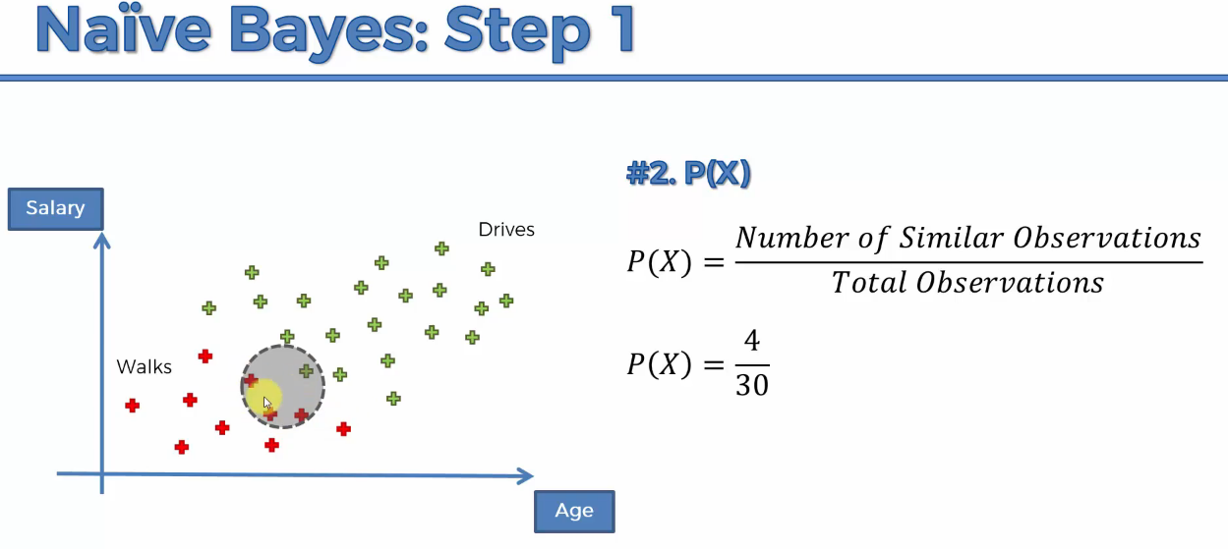

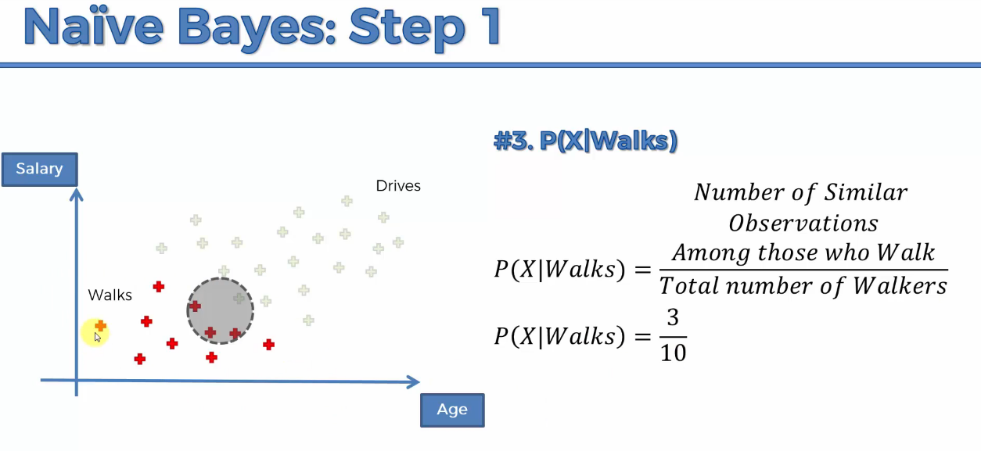

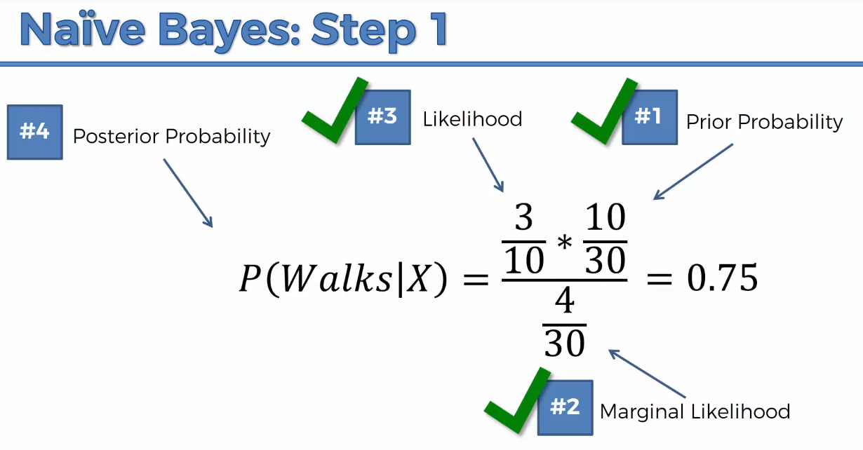

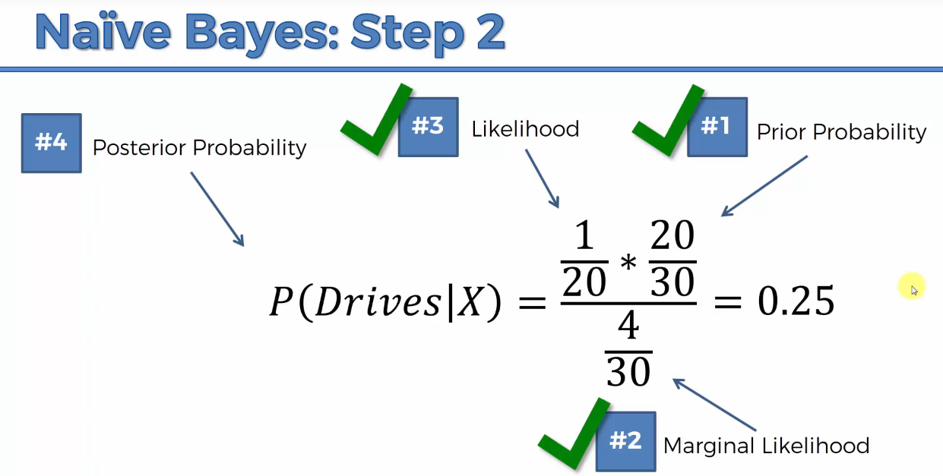

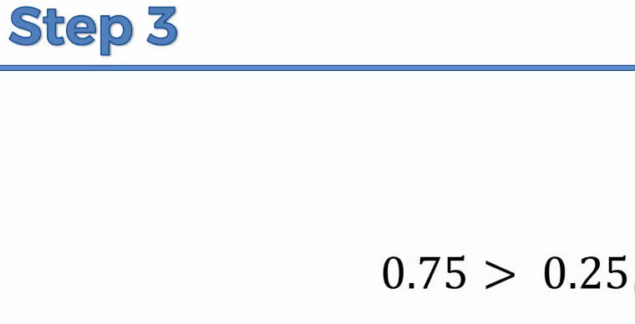

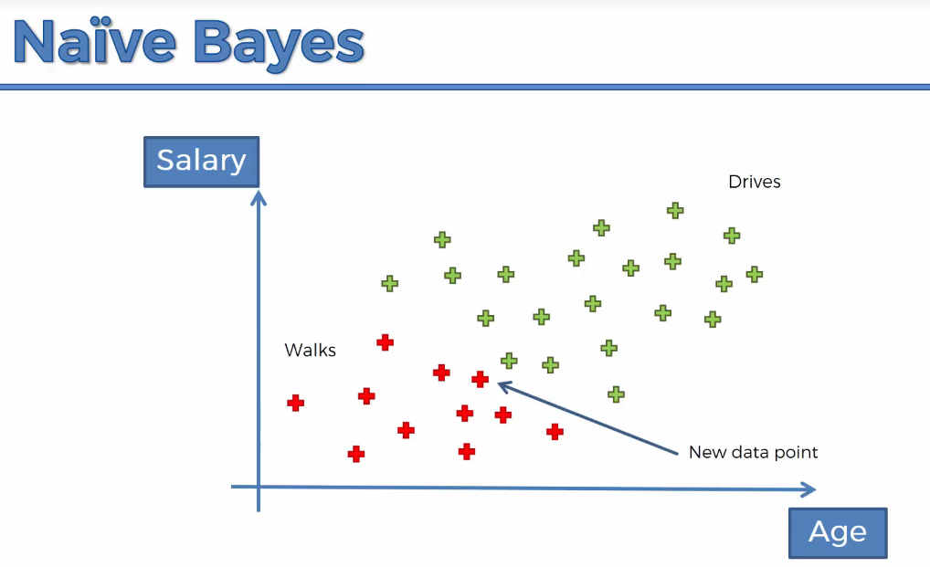

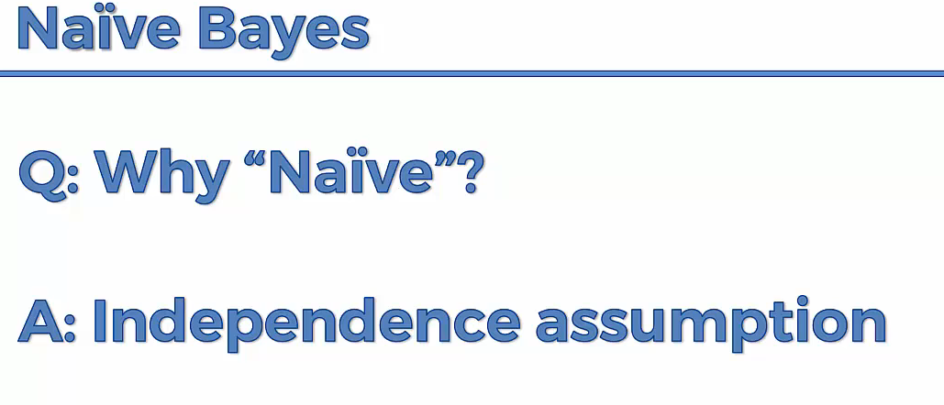

**Salary and Age should be independent. But as age increases, salary also increases. There is co-relation.**

**P(X) does not change,**

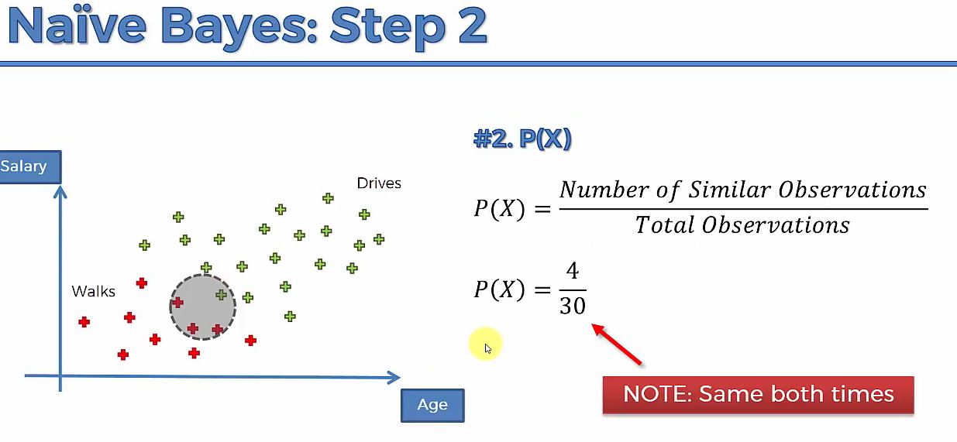

**Only if we compare the result, the below step is valid.**

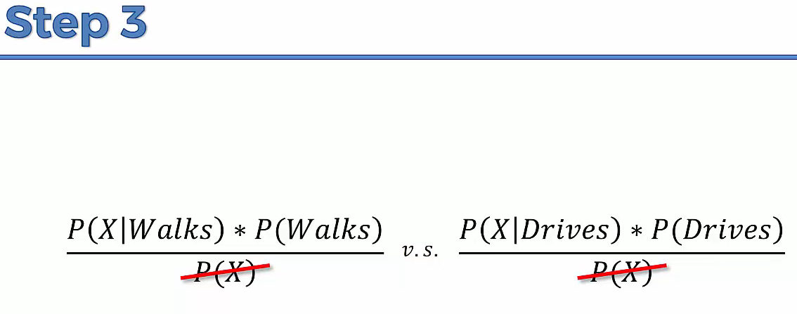



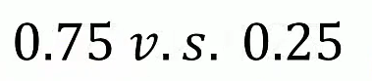

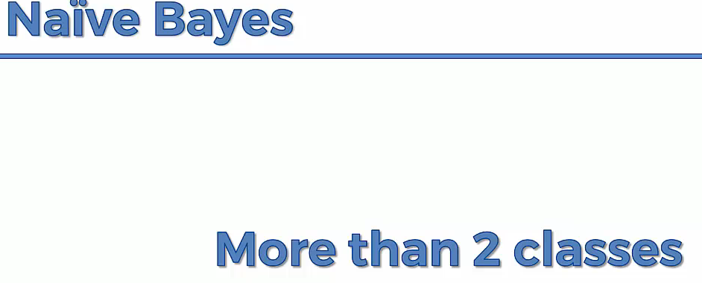

**The probability of every classes is found and the result is compared.**

**Result:**

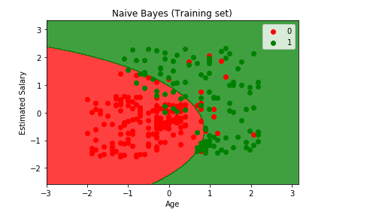

**we are getting smooth curve.**

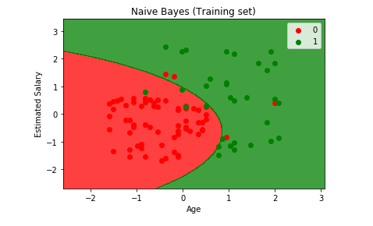

**Decision Tree –Classification**

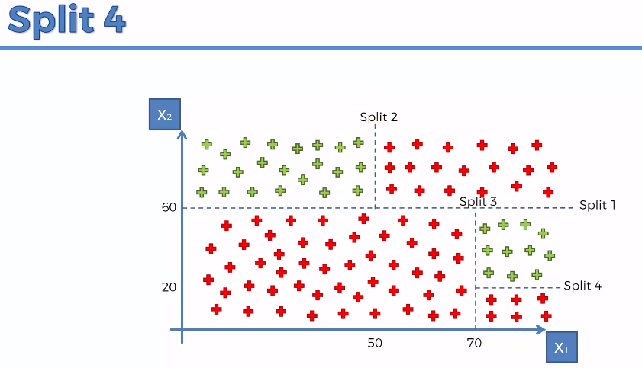

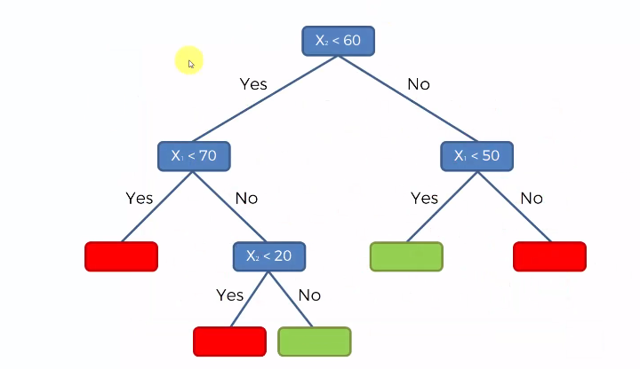

**It can handle multi-dimensional attribute**

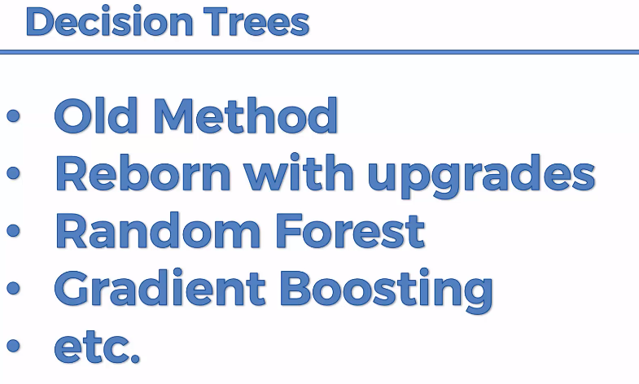

**Random Forest used in Image classification in phone and x-box movement while playing games.**

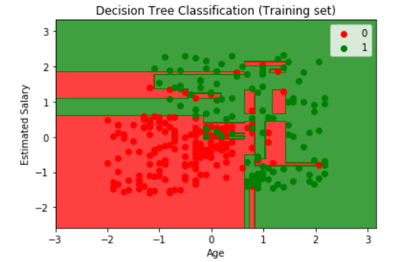

**Ensemble🡪When you take multiple machine learning to create a new machine learning model. Decision tree is clubbed to make random forest model.**

**Random Forest Classification:**

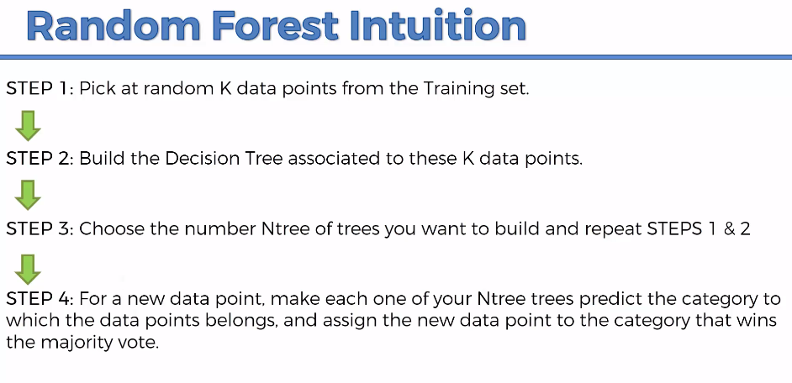

**It uses the power of crowd. To remove certain error and increase the accuracy.**

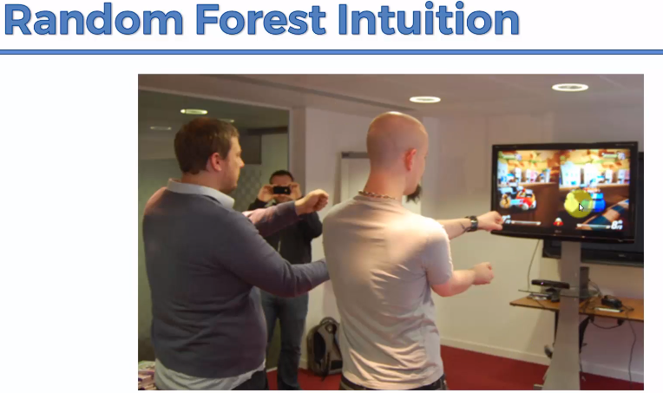

**X-Box used Random Forest.because it increases the processing speed with less hardware cost.**

**#no.of.tree is more some time can results in over-fitting on training dataset**

**n_estimators 🡪for each user there will be n_estimators trees, then the majority vote from the n_estimator tree is considered by the machine and it will classify.**

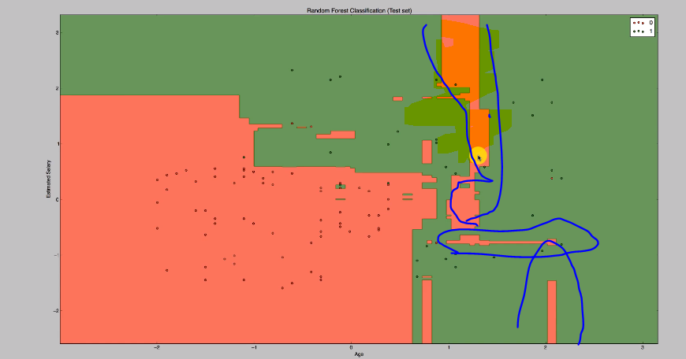

**The highlighted area is overfitted based on the training data set.**

**False Positives and Negatives**

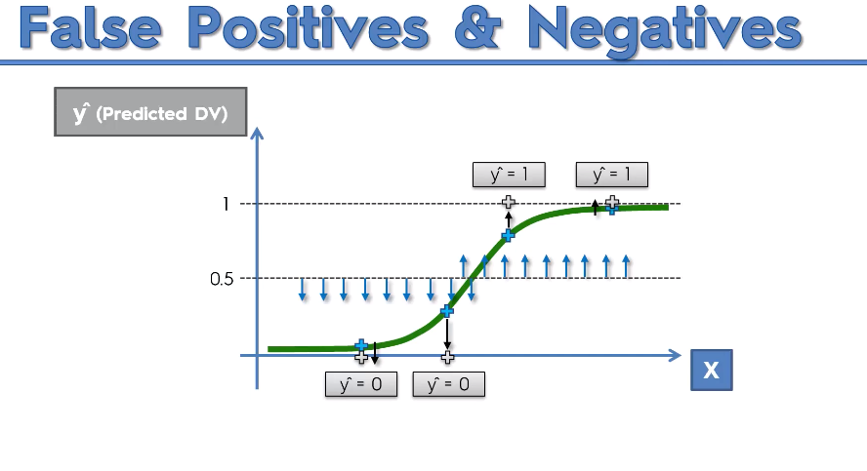

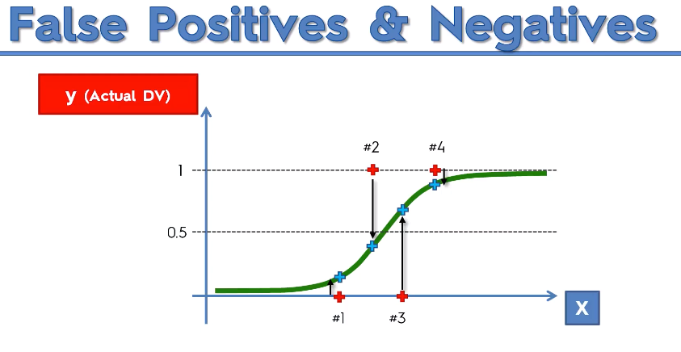

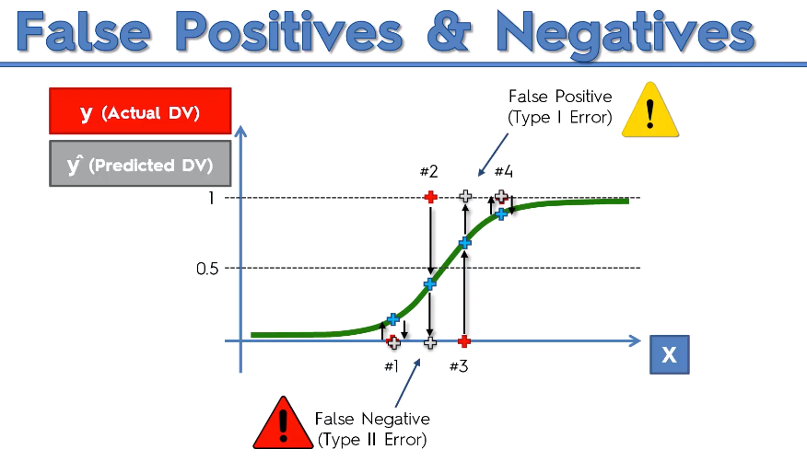

**(2)False(result) Negative(pred)🡪 no cancer but there was cancer🡪dangerous**

**(Negative(0) result but we predicted in a False way-opposite to result)**

**(3)False(pred) Positive(result)🡪 cancer exist but no predicted cancer🡪 Warning**

**(Positive(1) result but we predicted in a False way- opposite to result)**

**(4)True Positive🡪Cancer exists, we found it out there was cancer**

**(Positive(1) result but we predicted in a True way-match to result)**

**(1)True Negative🡪 NO cancer, we found out there was no cancer**

**(Negative(0) result but we predicted in a False way-match to result)**

**Negative, positive-🡪 0,1 vice-versa like yes or no**

**False, True🡪 Prediction result**

**Confusion Matrix**

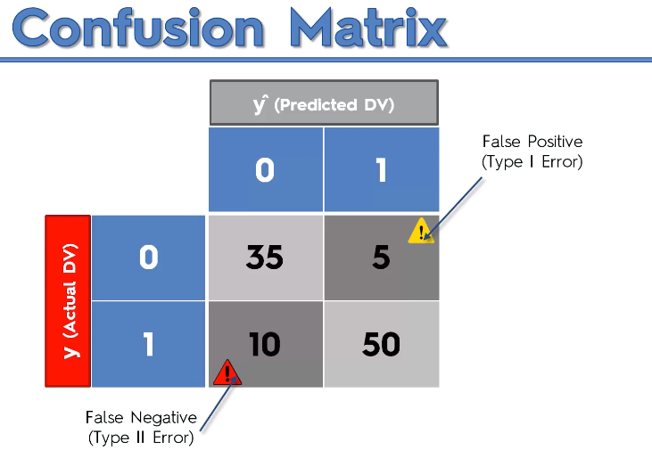

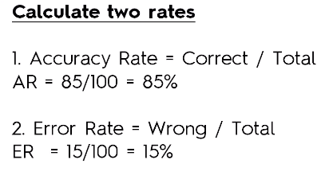

**Accuracy Paradox**

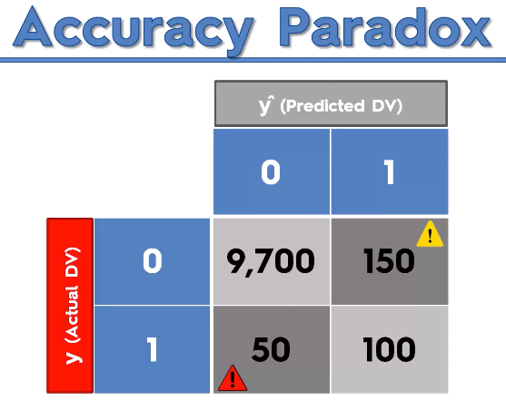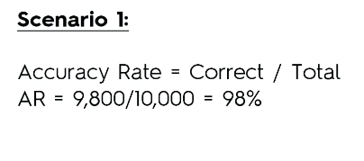

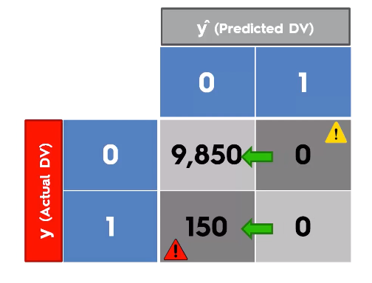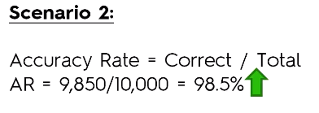

**You should not blindly follow the accuracy. It might miss lead the model.**

**CAP**

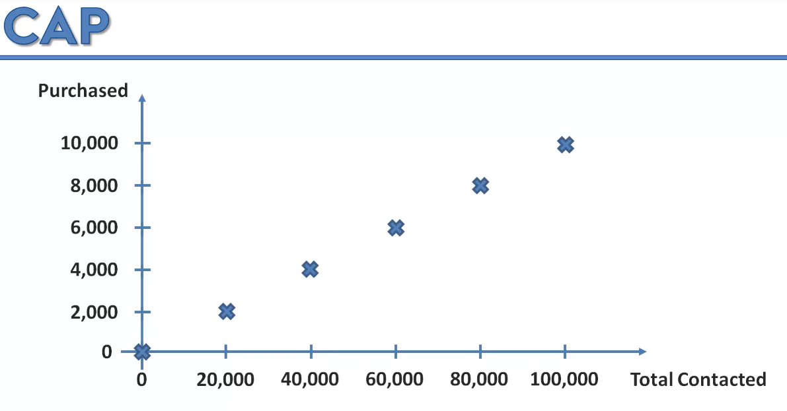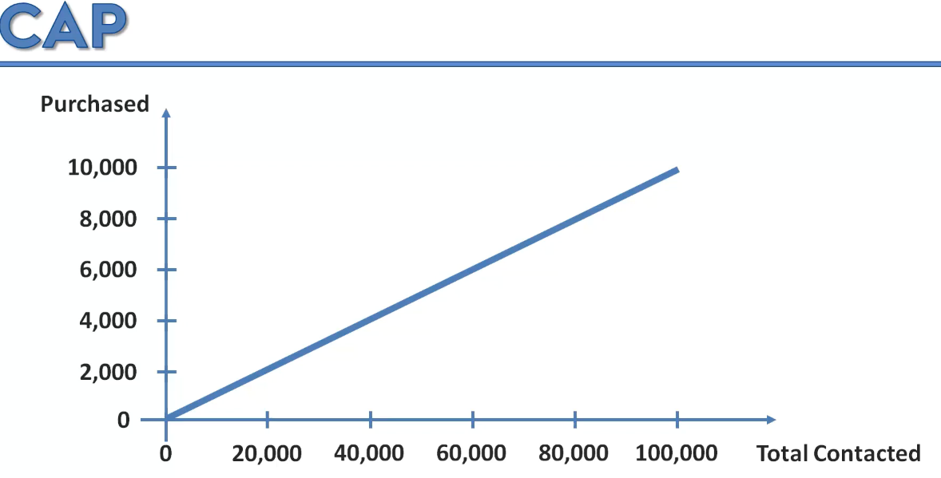

**Instead of sending randomly, we can choose the customer and build the model and target based upon the age, country, salary, interest.**

**Find the likelihood of their purchase.**

**After building the model for our dataset, it will reduce advertisement cost.**

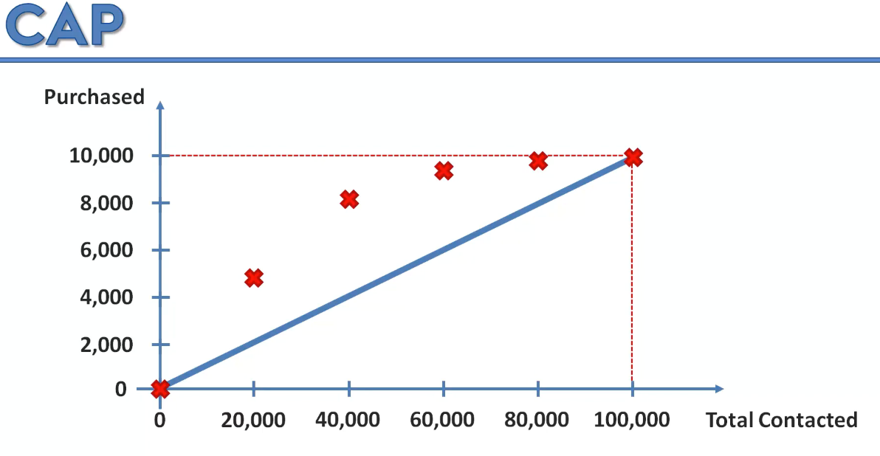

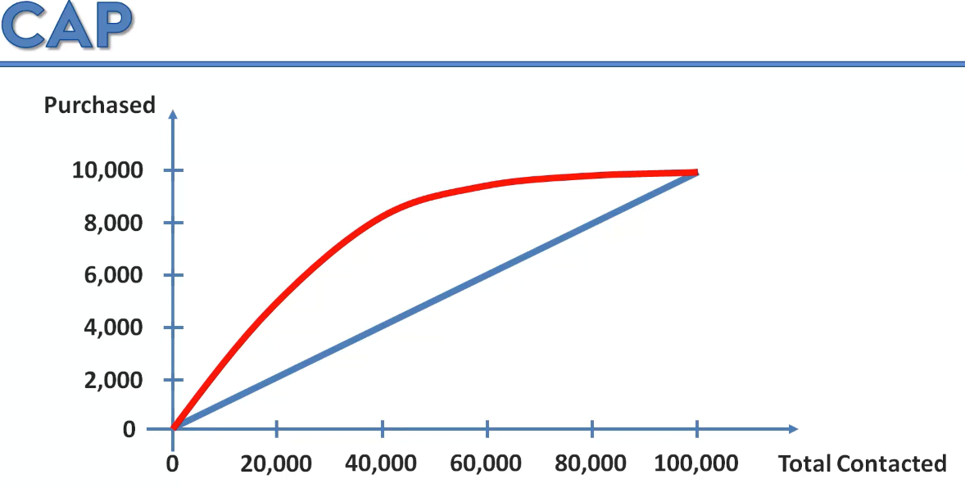

**If it is more away from blue line then the model is good.**

**CAP🡪 it is also called as gain chart by comparing with other model.**

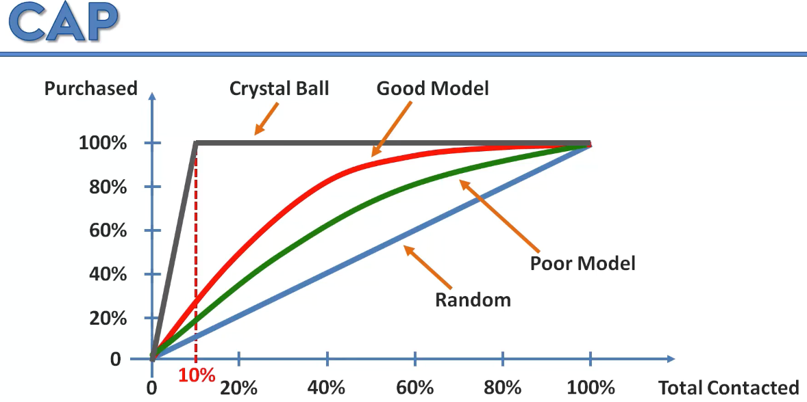

**All the 10 % will buy the product. With less contact more purchase.**

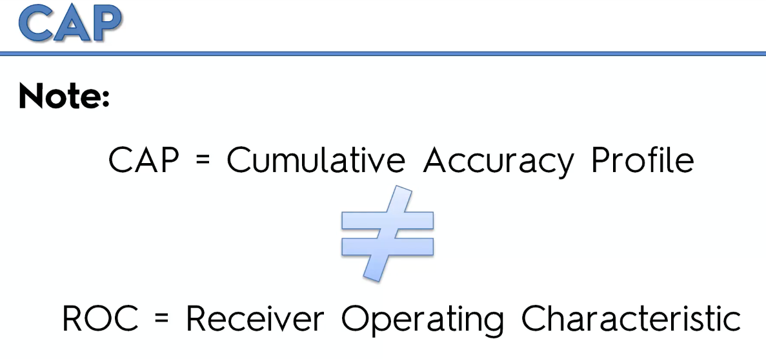

**Cap Analysis:**

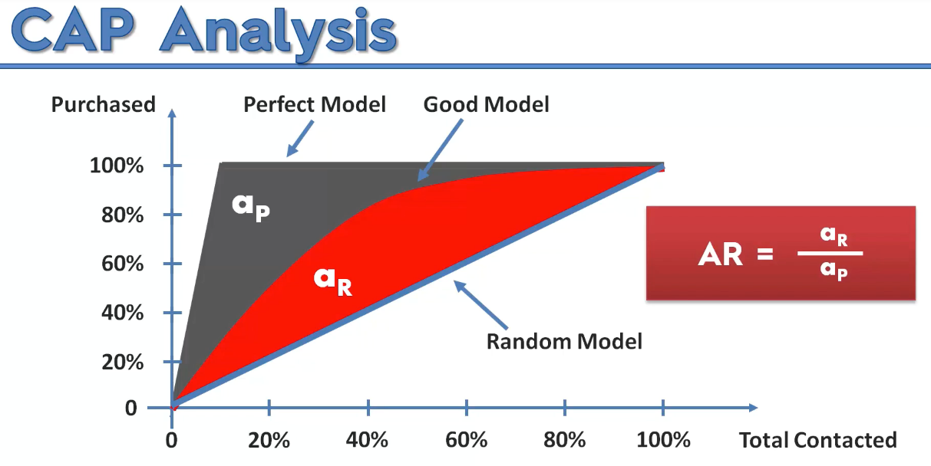

**Closer to 1 is good. Closer to 0 is bad.**

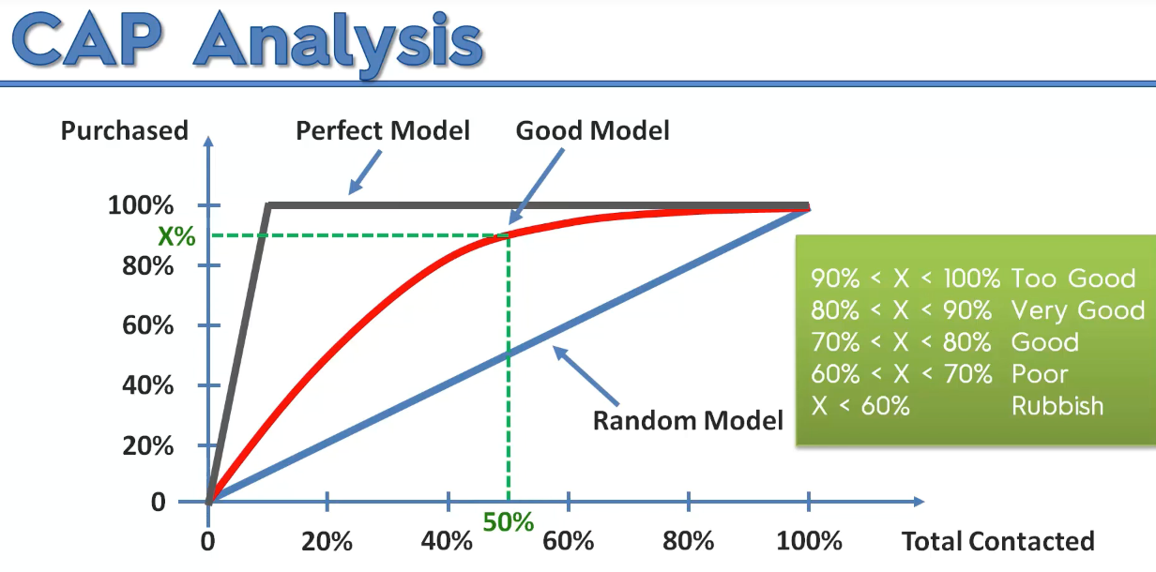

**90%-100% beware of over fitting.**

**80% to 90% is good.**

**CAP🡪 is used to evaluate the model performance by comparing each other.**

**ROC🡪 it is built on True positive and negatives.**

[**https://www.dataschool.io/roc-curves-and-auc-explained/**](https://www.dataschool.io/roc-curves-and-auc-explained/)

**ROC Curve**

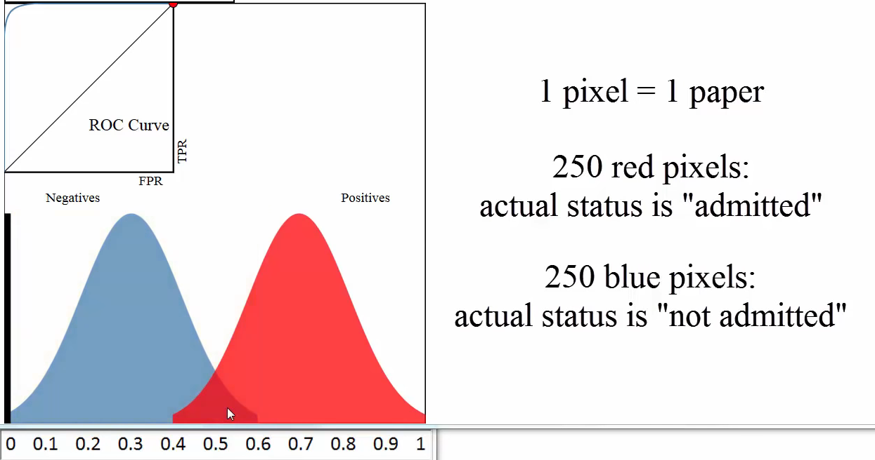

In this Part 3 you learned about 7 classification models. Like for Part 2 - Regression, that's quite a lot so you might be asking yourself the same questions as before:

1. What are the pros and cons of each model ?
2. How do I know which model to choose for my problem ?
3. How can I improve each of these models ?

Again, let's answer each of these questions one by one:

1. What are the pros and cons of each model ?

Please find [here](http://www.superdatascience.com/wp-content/uploads/2017/02/Classification-Pros-Cons.pdf) a cheat-sheet that gives you all the pros and the cons of each classification model.

2. How do I know which model to choose for my problem ?

Same as for regression models, you first need to figure out whether your problem is linear or non linear. You will learn how to do that in Part 10 - Model Selection. Then:

If your problem is linear, you should go for Logistic Regression or SVM.

If your problem is non linear, you should go for K-NN, Naive Bayes, Decision Tree or Random Forest.

Then which one should you choose in each case ? You will learn that in Part 10 - Model Selection with k-Fold Cross Validation.

Then from a business point of view, you would rather use:

- Logistic Regression or Naive Bayes when you want to rank your predictions by their probability. For example if you want to rank your customers from the highest probability that they buy a certain product, to the lowest probability. Eventually that allows you to target your marketing campaigns. And of course for this type of business problem, you should use Logistic Regression if your problem is linear, and Naive Bayes if your problem is non linear.

- SVM when you want to predict to which segment your customers belong to. Segments can be any kind of segments, for example some market segments you identified earlier with clustering.

- Decision Tree when you want to have clear interpretation of your model results,

- Random Forest when you are just looking for high performance with less need for interpretation.

3. How can I improve each of these models ?

Same answer as in Part 2:

In Part 10 - Model Selection, you will find the second section dedicated to Parameter Tuning, that will allow you to improve the performance of your models, by tuning them. You probably already noticed that each model is composed of two types of parameters:

* the parameters that are learnt, for example the coefficients in Linear Regression,
* the hyperparameters.

The hyperparameters are the parameters that are not learnt and that are fixed values inside the model equations. For example, the regularization parameter lambda or the penalty parameter C are hyperparameters. So far we used the default value of these hyperparameters, and we haven't searched for their optimal value so that your model reaches even higher performance. Finding their optimal value is exactly what Parameter Tuning is about. So for those of you already interested in improving your model performance and doing some parameter tuning, feel free to jump directly to Part 10 - Model Selection.

Now congratulations for having completed Part 3, and let's move on the next part of the journey:

